**Multi-layer Neural Network**

**ABSTRACT**

A multilayer perceptron is a feedforward neural network which can distinguish data that is not linearly separable. In this assignment, two multilayer perceptrons functioning in **heteroassociative** and **autoassociative** mode are designed, trained and tested on a small dataset of alphanumeric characters.These models are built based on 2 approaches :

* ***Approach 1***: ***Simple network with scalar output***
* ***Approach 2:Fully-connected Network with Image Output***

The models are also re-tested on ***noise-corrupted*** image dataset to observe the performance.

The goal of this project is to optimize the MLP to give the best possible results.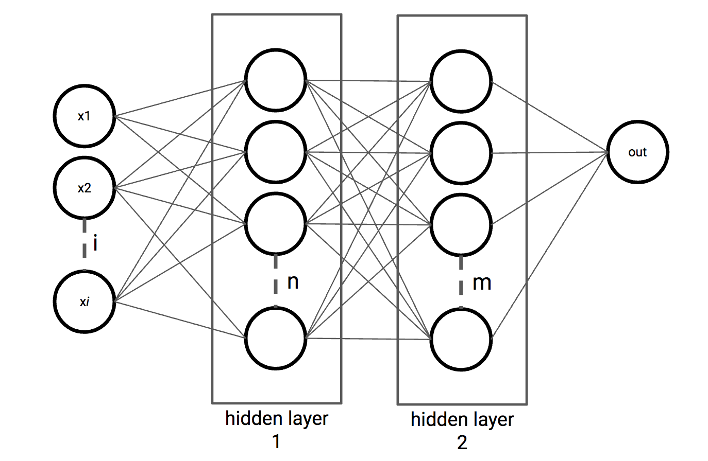

**Figure 1:** Sample Multi-layer Neural Network

**TABLE OF CONTENTS**

|  |  |  |
| --- | --- | --- |
| **S.NO** | **CONTENTS** | **PAGE NUMBER** |
| 1 | **Dataset Generation** | 4 |
| 2 | **Network Parameters** | 6 |
| 3 | **MLNN Model** | 8 |
| 4 | **Python code for MLNN** | 12 |
| 5 | **MLNN Performance for noiseless input** | 19 |
| 6 | **MLNN Performance For Noise-corrupted Input** | 21 |
| 7 | **Discussion** | 25 |
| 8 | **Appendix** | 27 |

**1. DATASET GENERATION**

The dataset was created by processing the **exemplar image** ( Fig.2) provided. Each alphabet and digit were individually cropped with the help of modules from **Pillow library** in Python. The individually cropped images were then re-sized to **16 X 16**. The images were then converted to **grayscale** from **RGB**. Following, the image matrices were normalized to have either a **0 or 1**. Essentially creating **binary images**.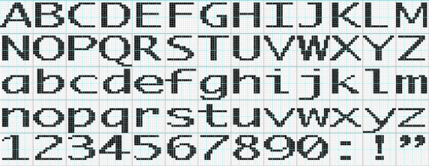

**Figure 2:** Exemplar GIF

The images obtained were then used for testing and training. **32 images** were selected to perform the **training** and 16 images of the training set were considered as validation set, they were the characters (**A,K,Q,B,a,b,e,g,h,i,j,m,D,p,s,t,u,w,E,x,y,z,1,2,4,5,6,8,0,G,H,I**). The **testing** was performed on the remaining **32 images** of the dataset. In the training set, we selected 32 images which were morphologically similar and which covered all the distinct features in the test set. Generally speaking **shape,size,color,orientation** etc are **morphological characteristics** of an image. **Orientation,corners,curve similarities** in the images are considered as **morphological characteristics**. So, based on these characteristics, the dataset was divided into train and test images.

An attempt was made to employ **SIFT(Scale Invariant Feature Transformation)** to identify the features of the images but the function used was not able to identify the key points for all of the images. Only for some of the images, the function was able to identify the key points and for some it was not able to. The code and the results of the **SIFT function** have been discussed in the **appendix**.

***TRAINING SET***

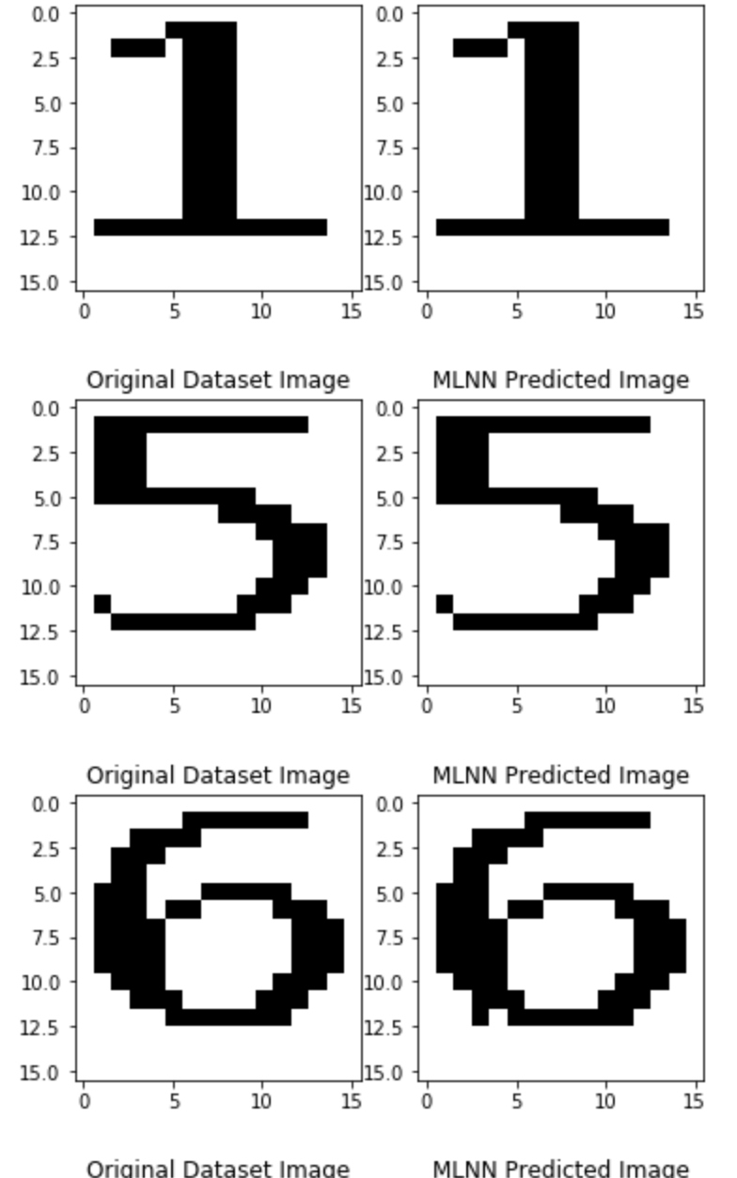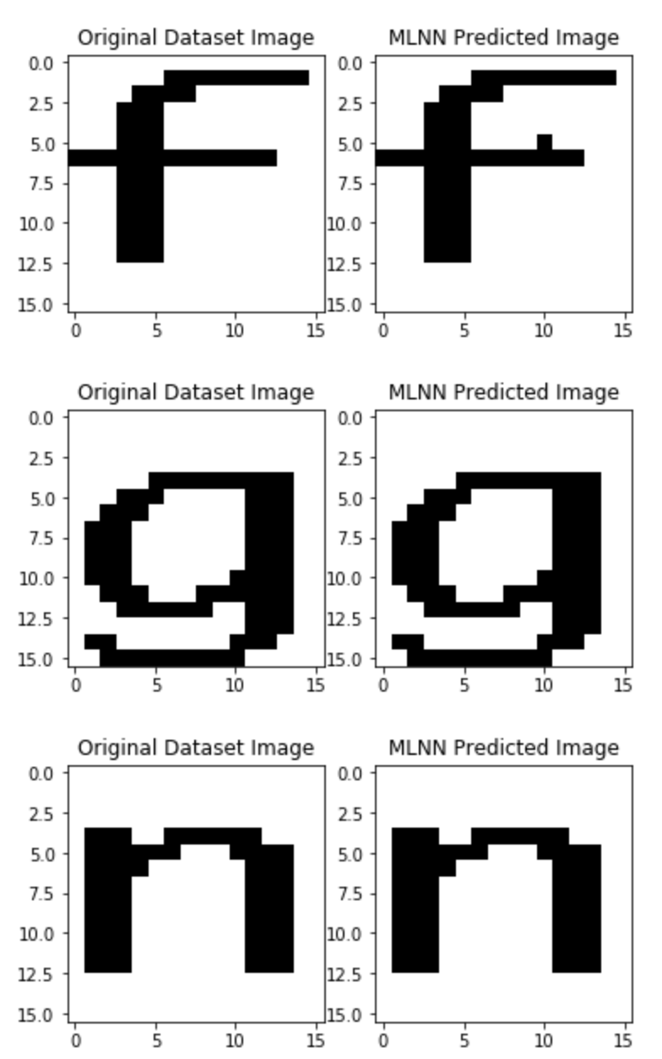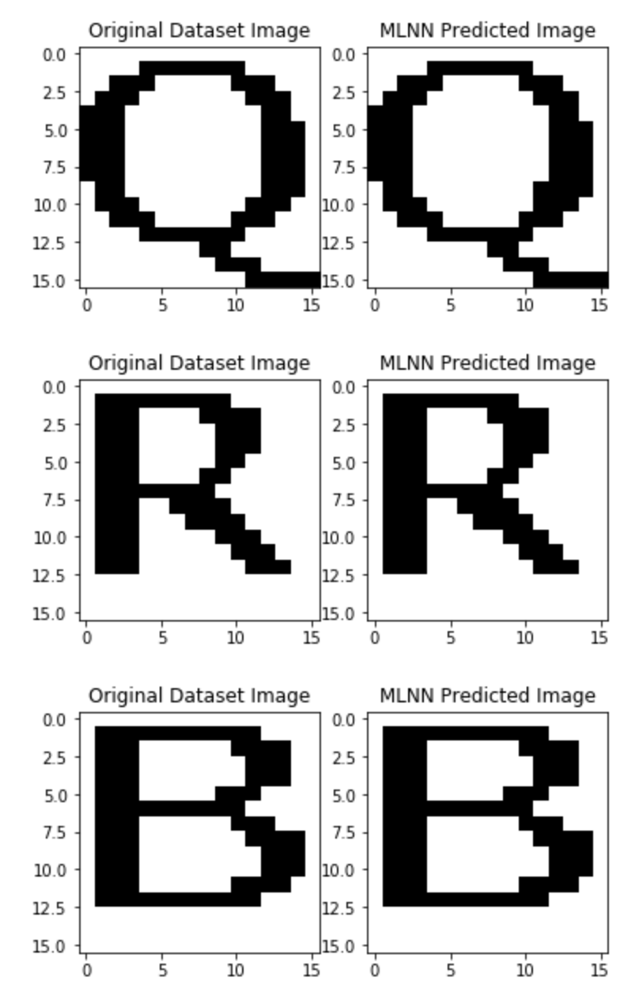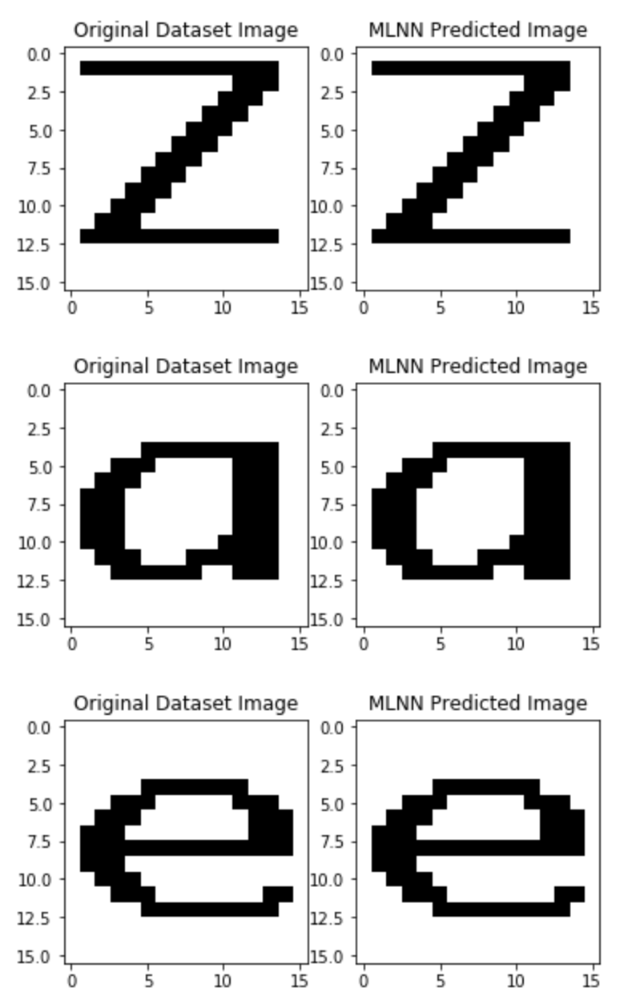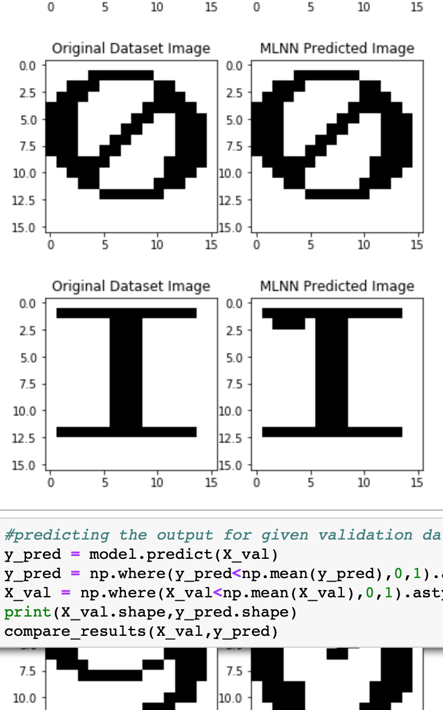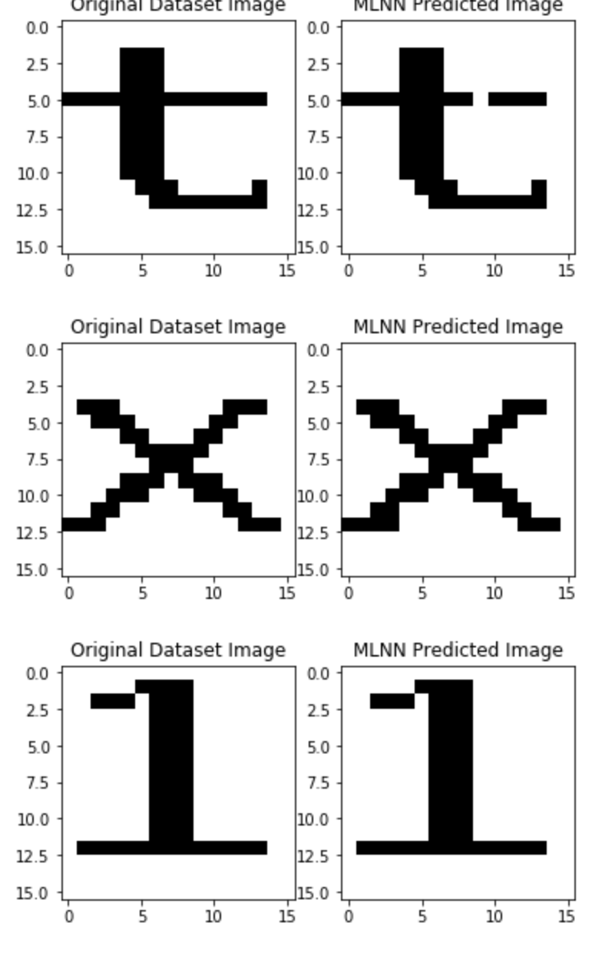

**Figure 3:** training set

***VALIDATION SET***

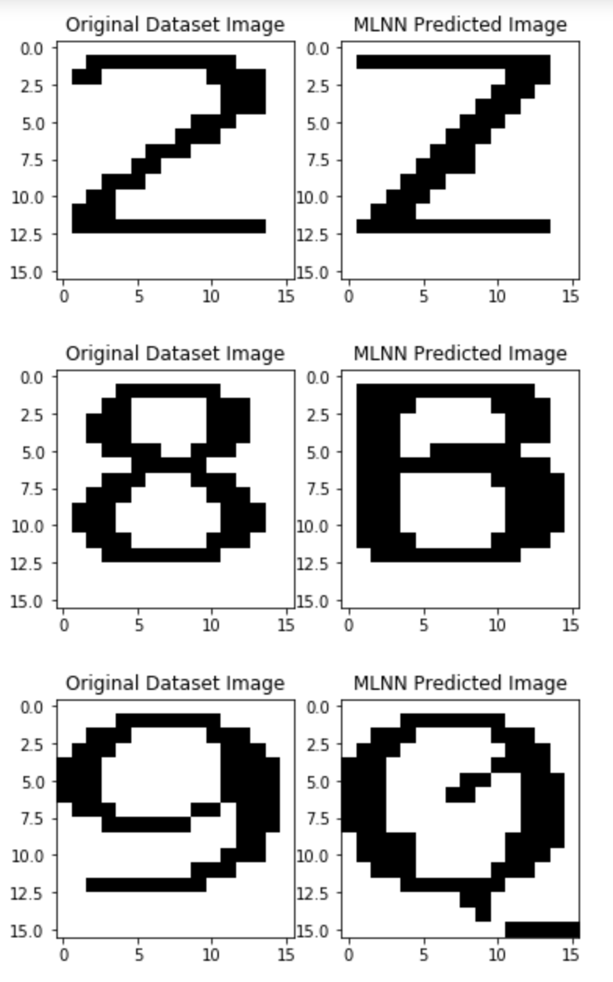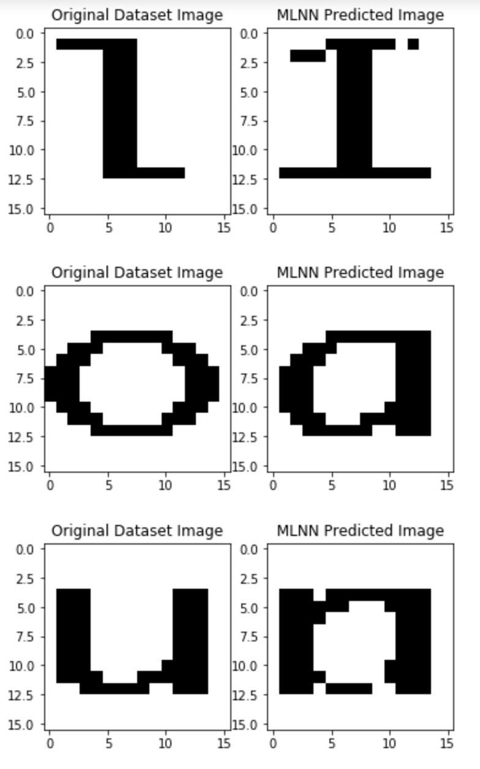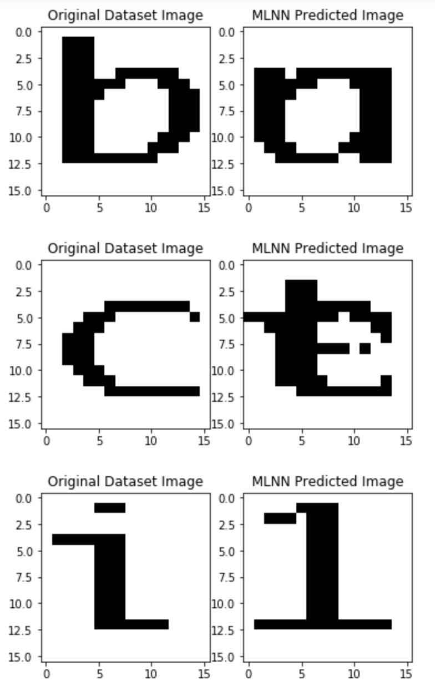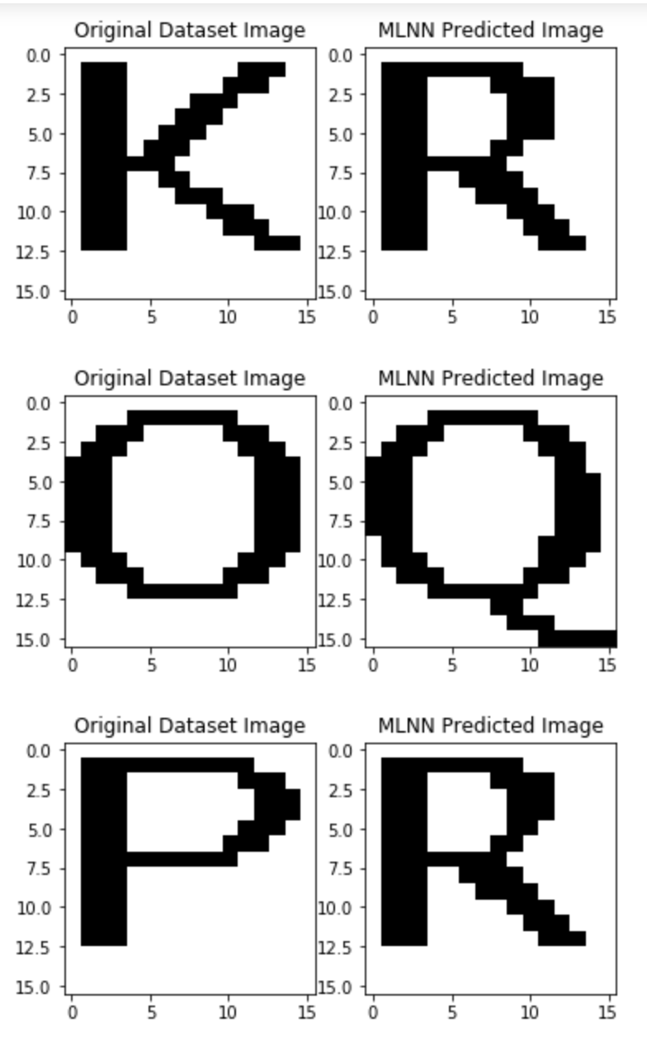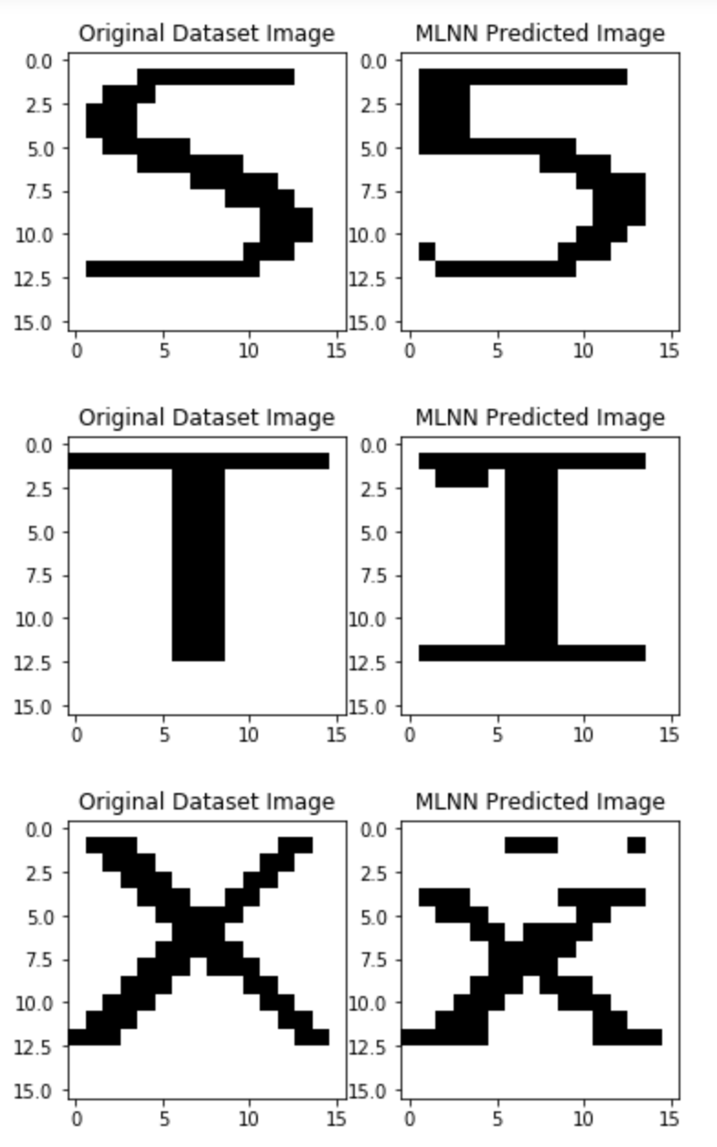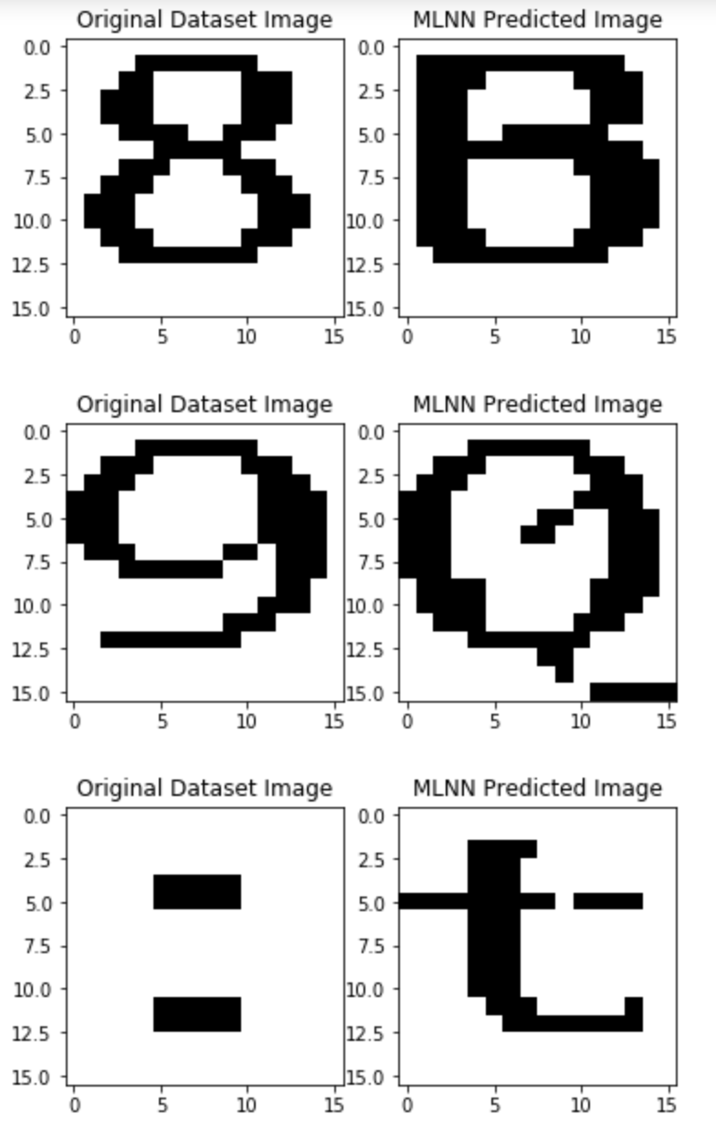

**Figure 4:** validation set

***TEST SET***

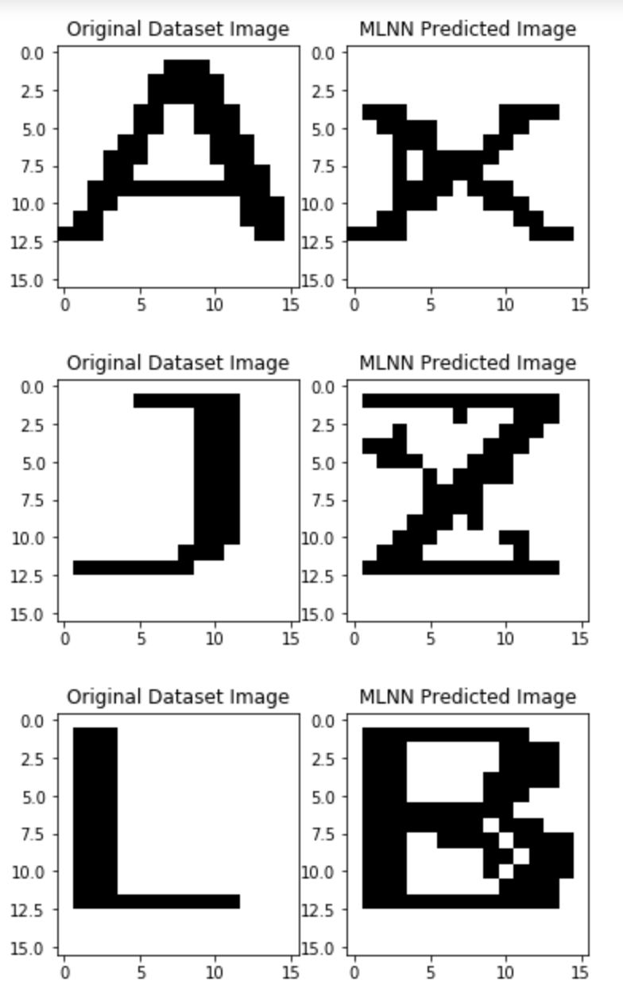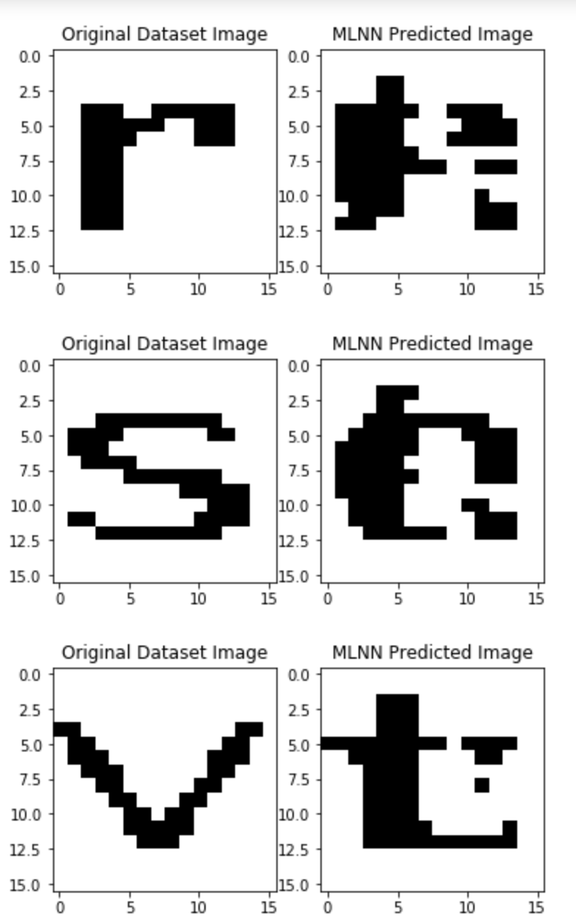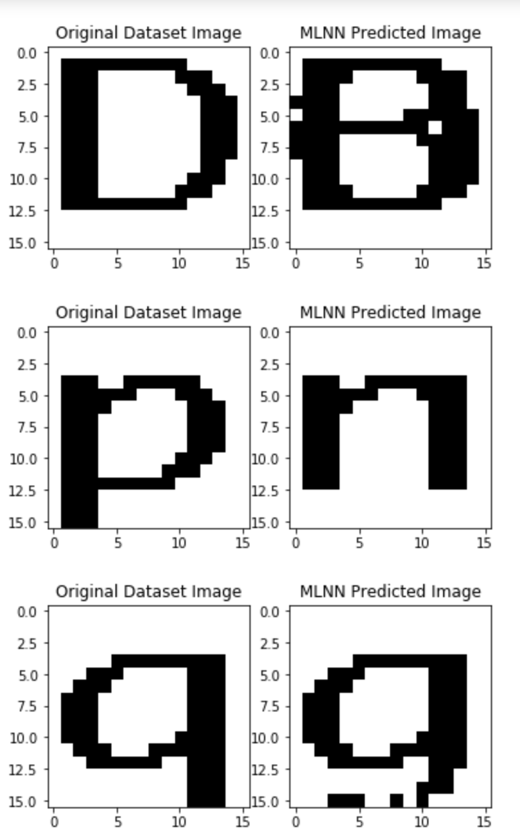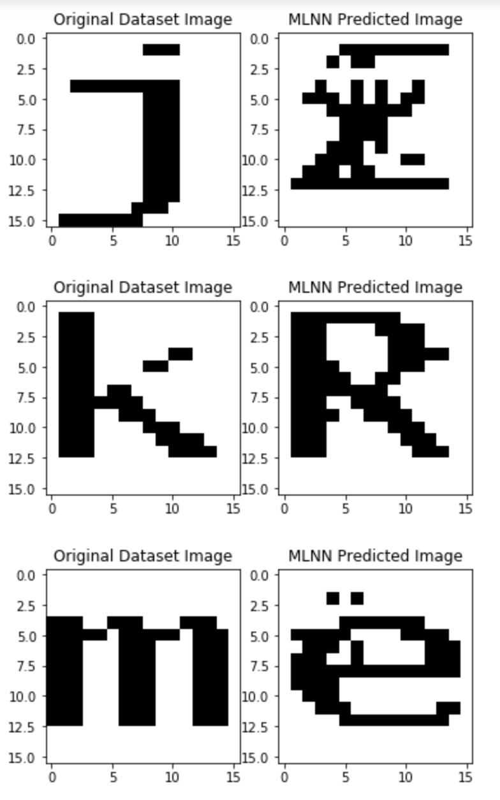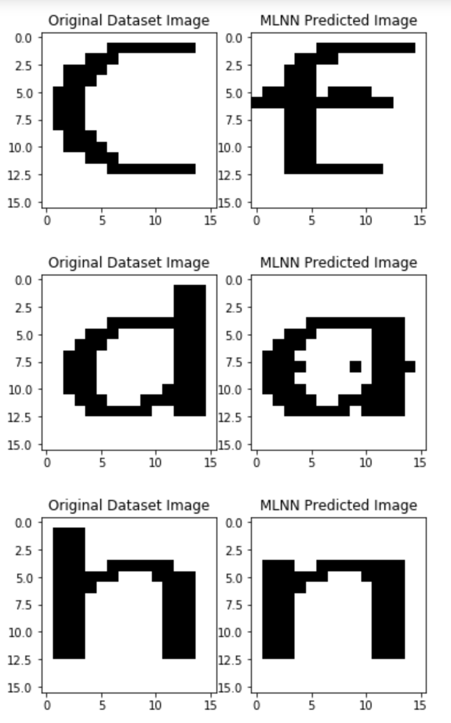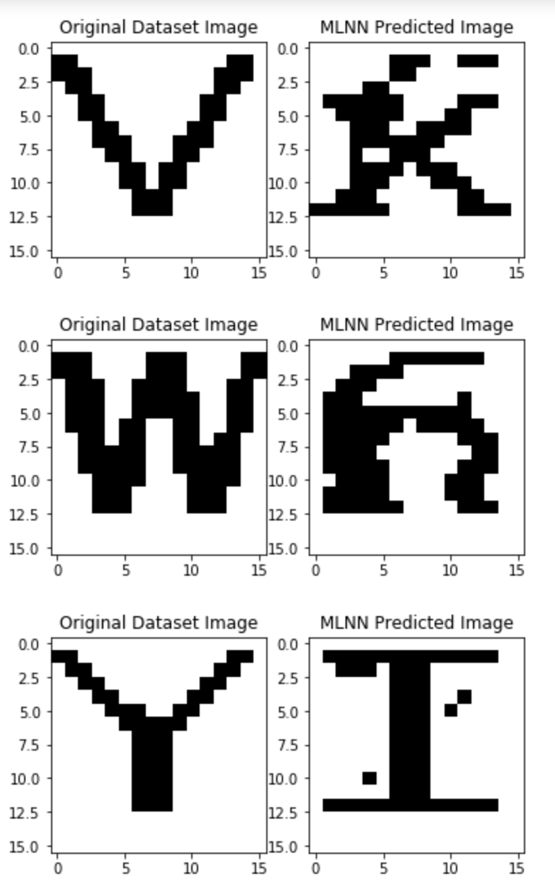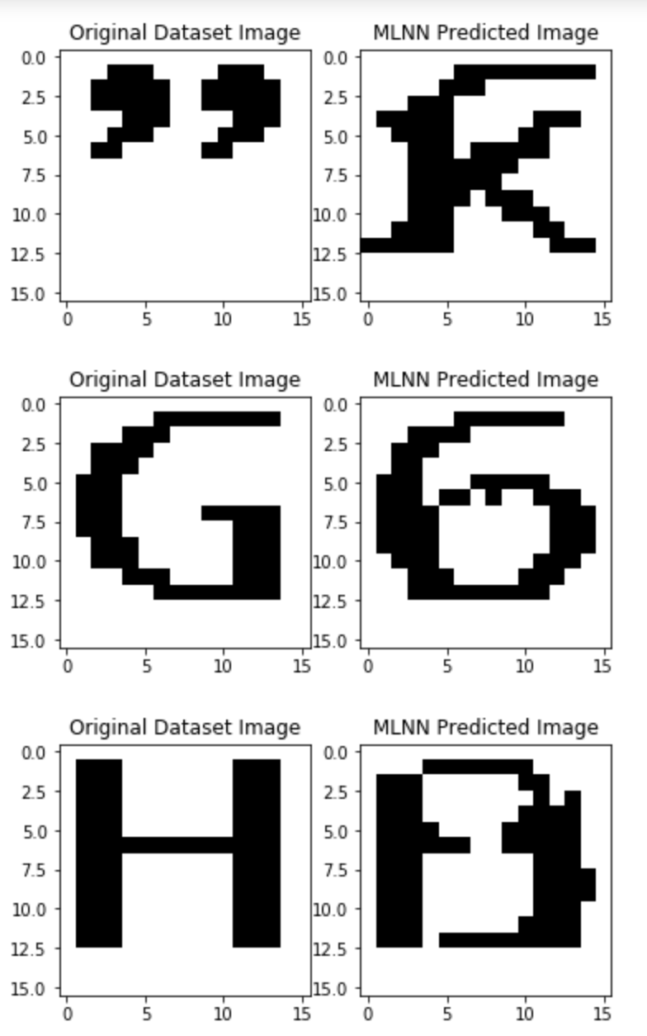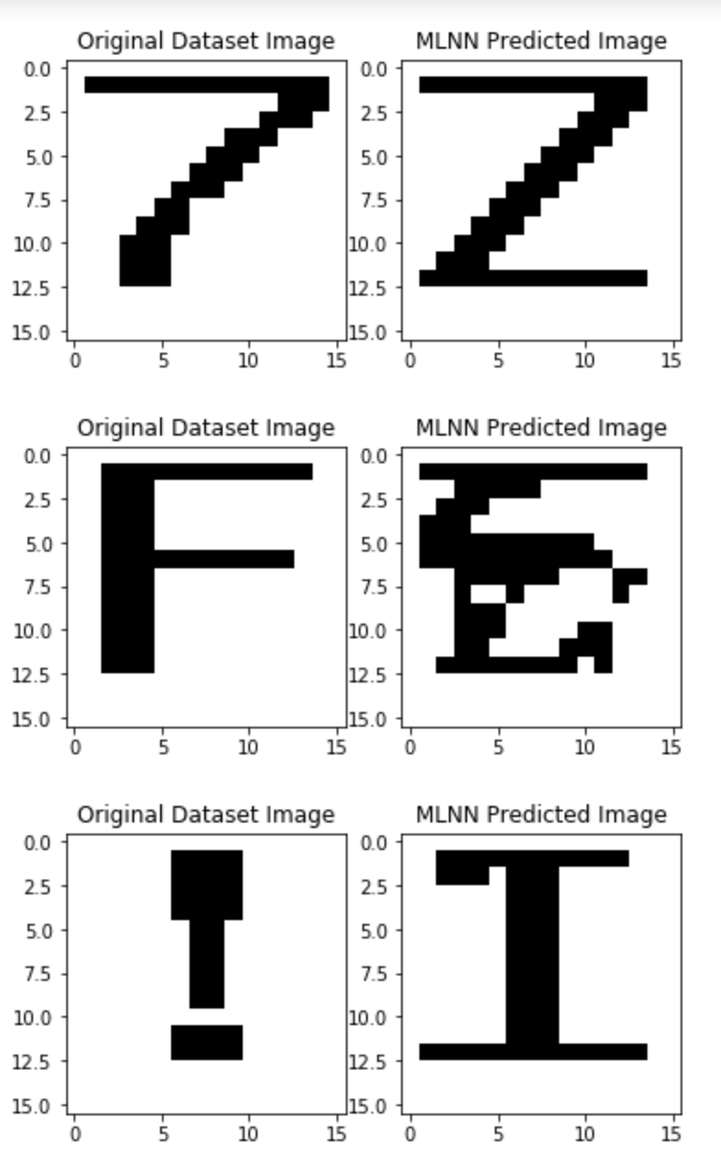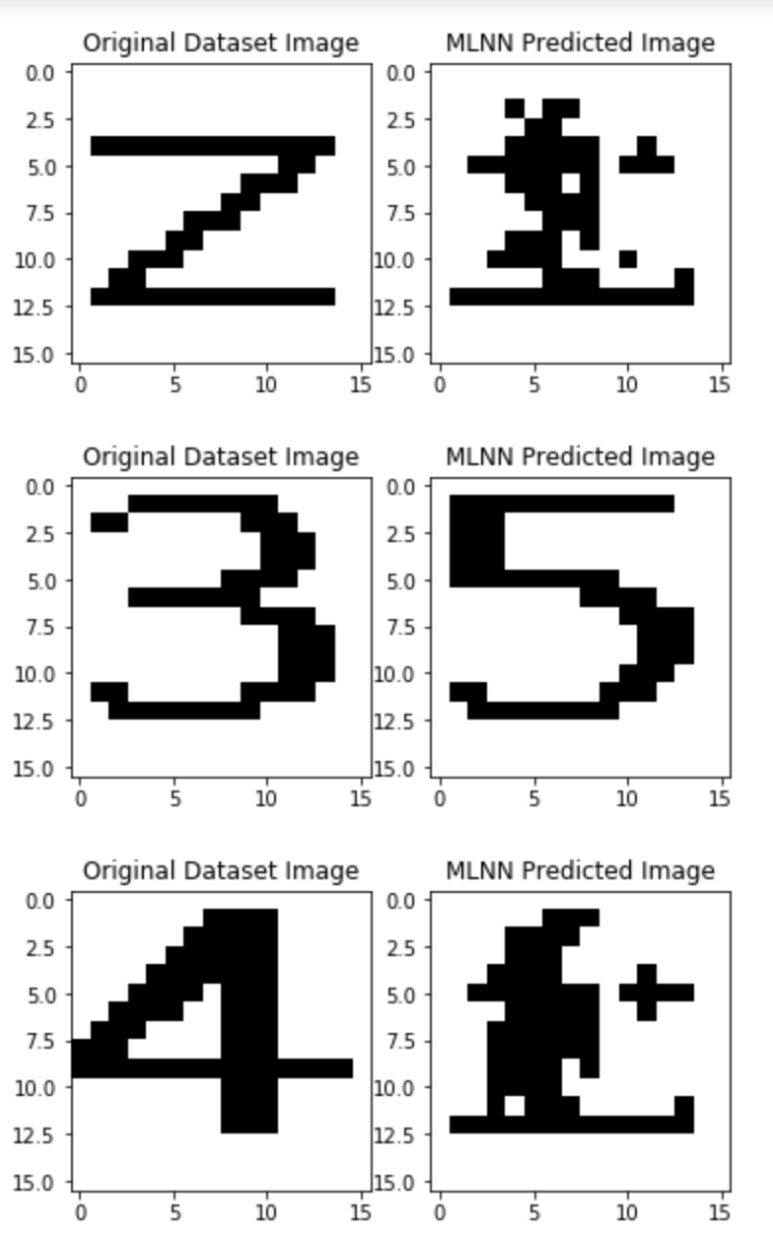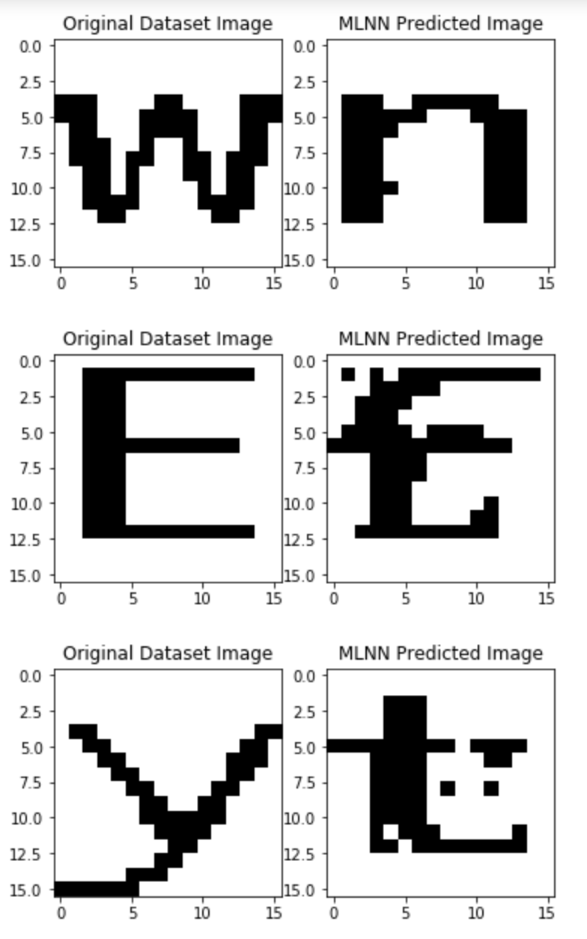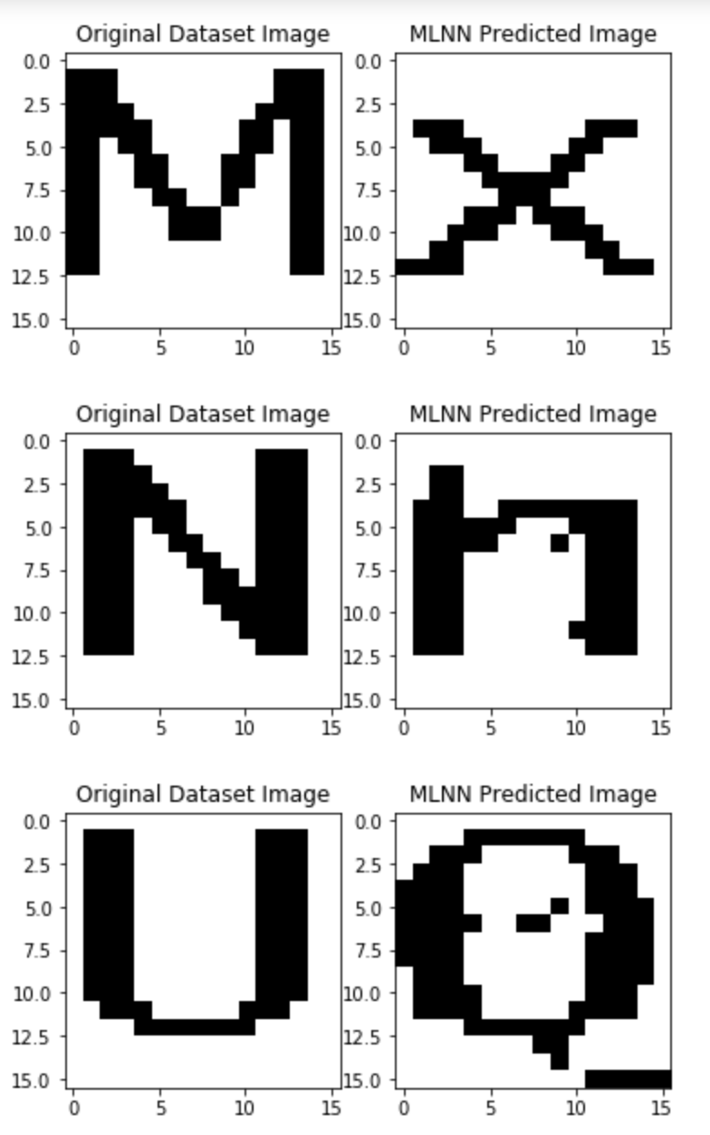

**Figure 5 :**test set

**2. NETWORK PARAMETERS**

***Heteroassociative Multi-layer Neural Network (MLNN1)***

1. **Input:**16x16 pixel images

2. **Output:** index associated with the alphanumeric character

3. **Number of weights:** 256, bias 1 is included.

4. **Activation function:** ReLu

5.**Optimizer**: SGD (Stochastic Gradient Descent)

5.**Epochs**:30,50,100,150,500.(tabulated below)

6. **Learning rate:** 0.001

7. **Evaluation metrics:** Fh,Ffa

|  |  |
| --- | --- |
| **Number of iterations**  **(epochs)** | **Loss** |
| 30 | 2.7 |
| 50 | 1.51 |
| 100 | 0.2829 |
| 150 | 0.50 |
| 500 | 0.0335 |

**Table 1**: MLNN 1 loss tabulations during training

The number of **epochs** were chosen in a manner to improve the performance of the model.

It is observed that as the **number of epochs** were **increased** that there was a **drop in the loss** during the **training**. This could be that as the number of epochs were increased the model was able to learn more. It has also been observed that as the number of epochs have increased drastically, it led to **over-fitting** of the model which led to a great increase in the loss of the model. Hence, the number of epochs was chosen in such a way that the loss was minimum. In the case of the heteroassociative multi layer neural network it was chosen to be **500** epochs as it gave the least amount of loss without the problem of **overfitting.**

***Autoassociative Multi-layer Neural Network (MLNN2)***

1. **Input:**16x16 pixel images

2. **Output:** 256 nodes

3. **Number of weights:** 256 X 256 =64K weights

4.**Weight matrix**(Initially, weights were generated randomly using a random function)

5. **Activation function:**Sigmoid

6. **Learning rate:** 0.001

7. **Epochs**: 1500

8. **Optimizer:**Adam

9. **Evaluation metrics:** Fh,Ffa

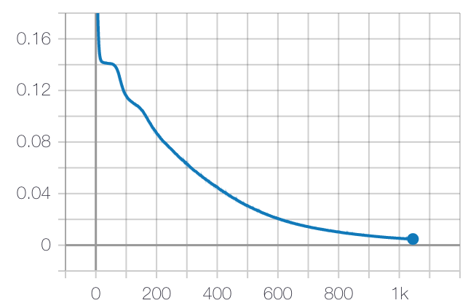

**Figure 6**:MLNN 2 loss tabulations during training

While executing the neural network, the gradient descent method adopted during optimization converges loss on the training data only and may sometimes lead to overfitting as the number of epochs increase. Hence, we use **early stopping** to avoid this situation and ensure generalization of the model. Initially the number of epochs were set to 1500 but the learning process halted after 1046 epochs after applying early stopping while monitoring loss on validation data. The figure above shows the variation of loss with increase in epoch number.

**3. MLNN MODEL**

**3.1 Heteroassociative Multilayer Neural Network (MLNN1)**

The model is given **256 inputs** which are the elements of the image matrix. Followed by **257**

**weights** (including a bias term with weight 1 ). The output will be an integer output corresponding to the **index**  that will vary from **i = 1 to i = 32** (for the indices of the alphanumeric pattern images).

The **governing equation** is given as :



The model consists of several layers with the **initial layer** being the **input layer** that takes in the **256** inputs ( pixel values of the image). Followed by **hidden layers** added in a **sequential fashion**. The **hidden layers** are chosen with certain **activation functions** (ReLu) and a specific number of **nodes** in such a manner to **improve** the **performance** of the model. The number of nodes in the **hidden layers** are as follows: **128, 128, 64.**

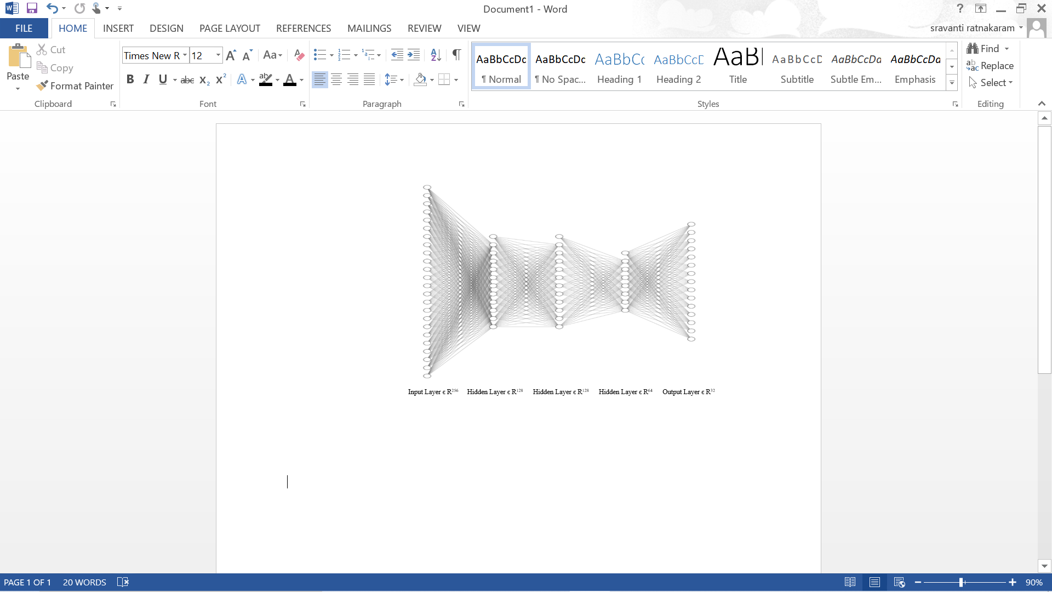

**Figure 7:** Heteroassociative Multilayer Neural Network architecture

The model was trained with **32** alphanumeric images that are **morphologically similar** in the best interest of better prediction of unseen images in the test set. Later, **testing** was done on all the remaining **32 images**. The subset of the 32 training images, that is, **16 images** were used for **validation**.

**ReLu Activation Function:**

The Rectified Linear Unit is an activation function used in deep learning models. The function returns **0** if it receives any **negative input**, but for any **positive** value ***x*** it returns that **value back**. So it can be written as:

***F(x) =max (0, x)***

**Figure 8:** Graphical representation of ReLu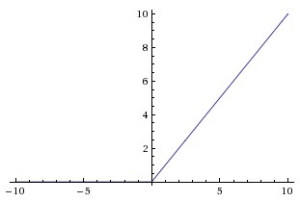

Relu activation function is a more granular approach to add non-linearity into the network. It is widely used while training due to its speed and efficiency.

**Stochastic Gradient Optimizer (SGD):**

This is an algorithm responsible for allowing neural networks to converge, i.e. the model shifts towards the optimum of the cost function. In stochastic gradient descent (SGD), we only calculate the cost for a training exemplar at each step. The optimizer is defined by: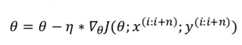

**θ is a parameter, e.g. Weights, biases and activations**

**η is the learning rate**

**∇ is the gradient, which is taken of J**

**J is formally known as objective function**

**3.2 Autoassociative Multilayer Neural Network (MLNN2)**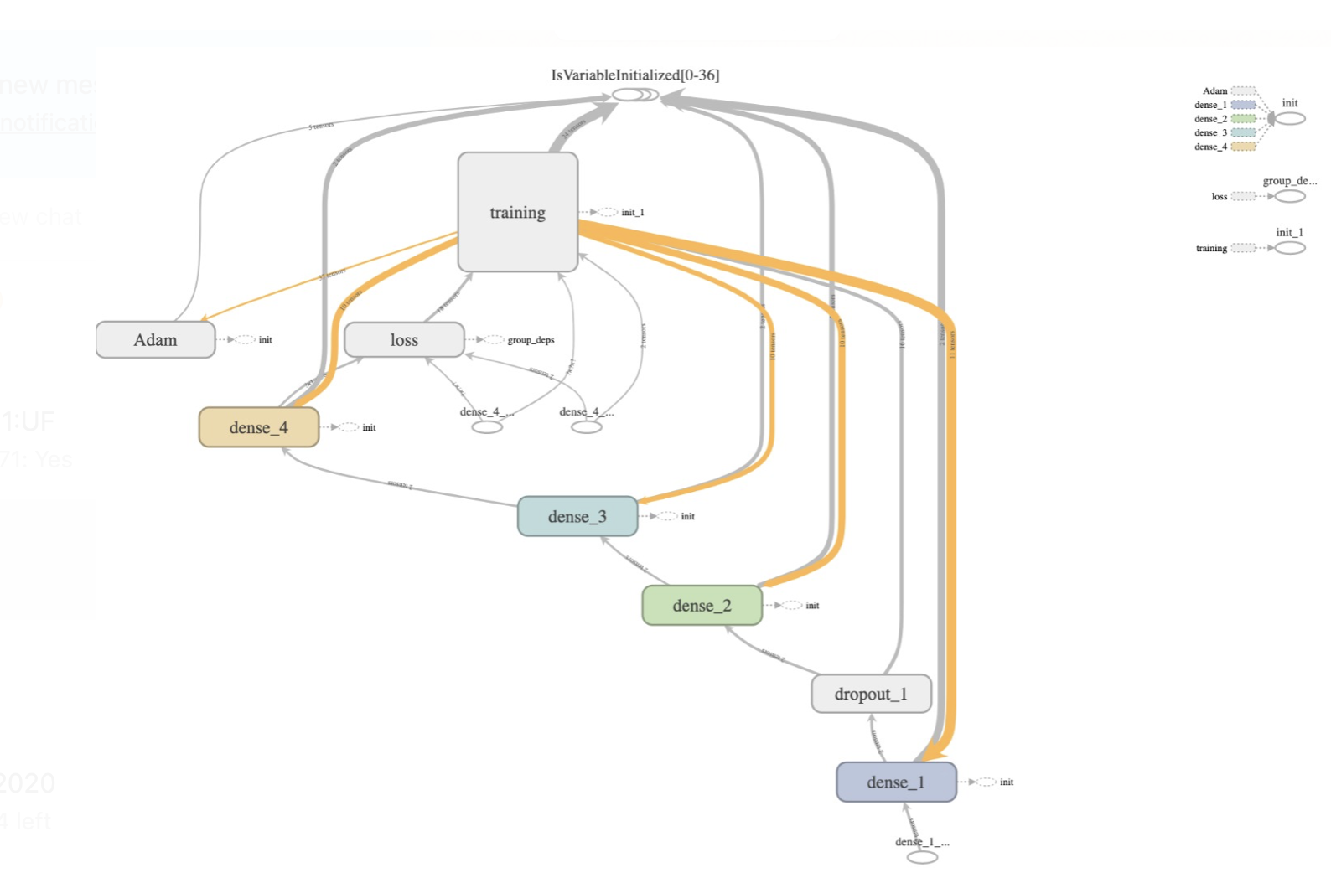

**Figure 9:** MLNN 2 network architecture pictorial representation

**Sigmoid Function:**

Since every neuron must predict a value within the range of [0,1], we chose sigmoid activation function. The sigmoid function can be represented as:

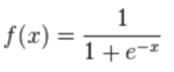

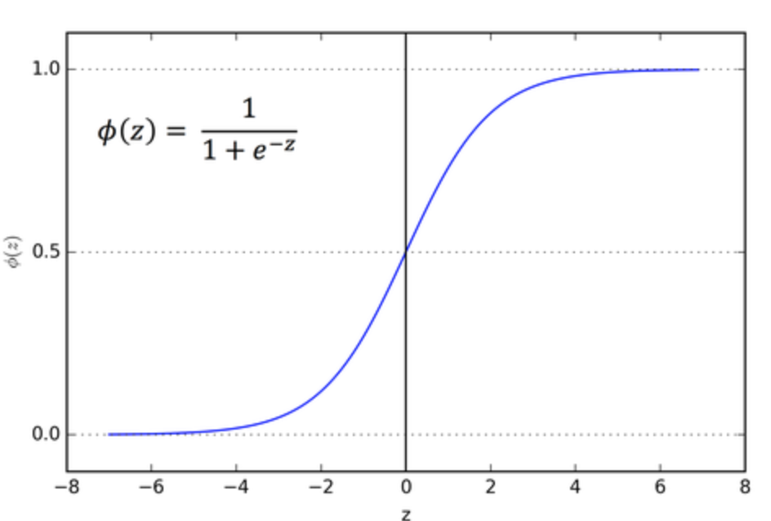

**Figure 10:** Graphical representation of sigmoid activation function

**Adam optimizer:**

Optimizer used was Adam optimizer. **Adam** can be looked at as a combination of RMSprop and Stochastic Gradient Descent with momentum. It uses the squared gradients to scale the learning rate like RMSprop and it takes advantage of momentum by using the moving average of the gradient.

**Bagging:**

Bagging is an effective regularization technique that has been implemented into the model to reduce variance from the training data and improve the accuracy of the model. This is achieved by training the model with a subset of the training data from the larger dataset. This also ensures the model is more generalized.

An attempt was made initially without bagging and using the same validation set at every epoch which resulted in a poor performance of the model. Different 16 images of validation set were used from 32 images of training set at each epoch. This reduced the variance and improved the accuracy of our model.(refer to 4.2 **Compilation and Evaluation of the model**)

**4. PYTHON CODE FOR MLNN**

**4.1 Python code for Heteroassociative Multilayer Neural Network (MLNN1)**

***Dataset Generation***

The following code snippet depicts the conversion of 64 cropped images into black and white images based on a threshold value (127.0)

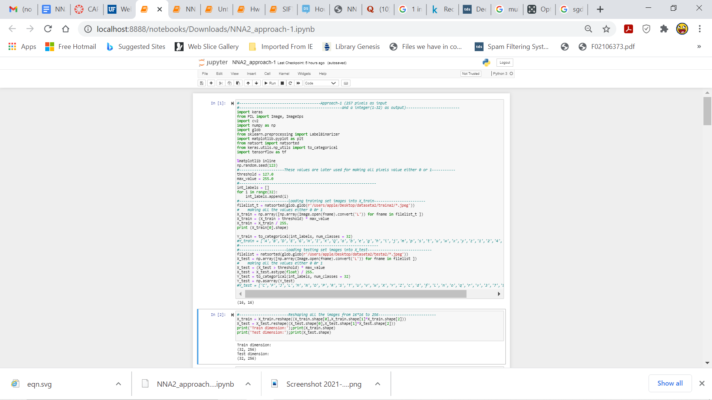

***Model Initialization***

In the code snippet below the model has been initialized with an input layer, followed by 3 hidden layers and an output layer. ***The TensorFlow*** library has been used. The model was implemented using ***Keras***. After trying several combinations of number of nodes and activation functions, it was noticed that the model performed best when the number of nodes in the hidden layers were ***128, 128 and 64*** and the activation function for each hidden layer is the **ReLu** function.

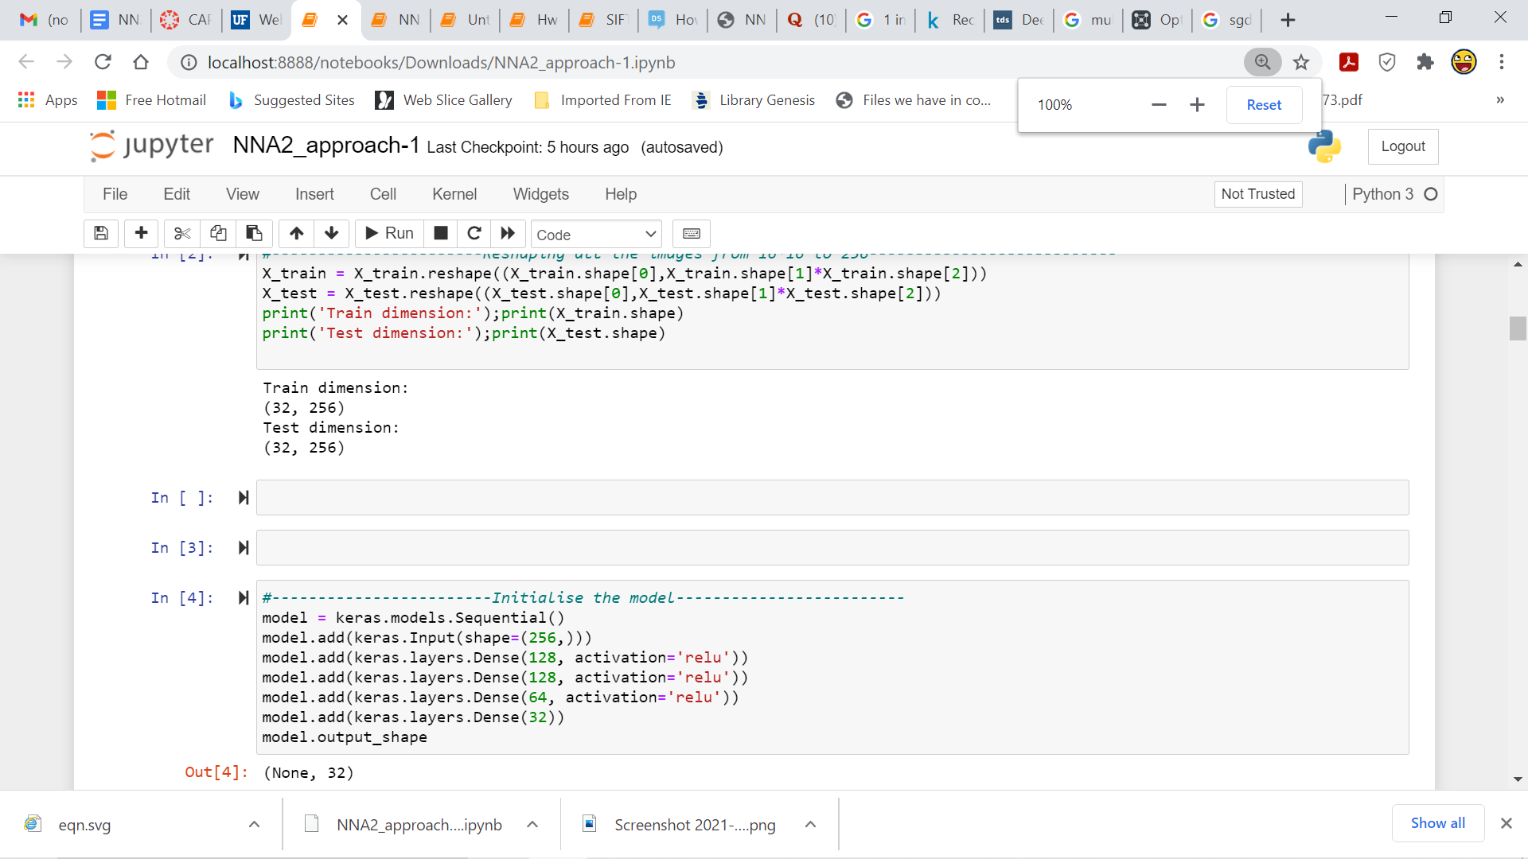

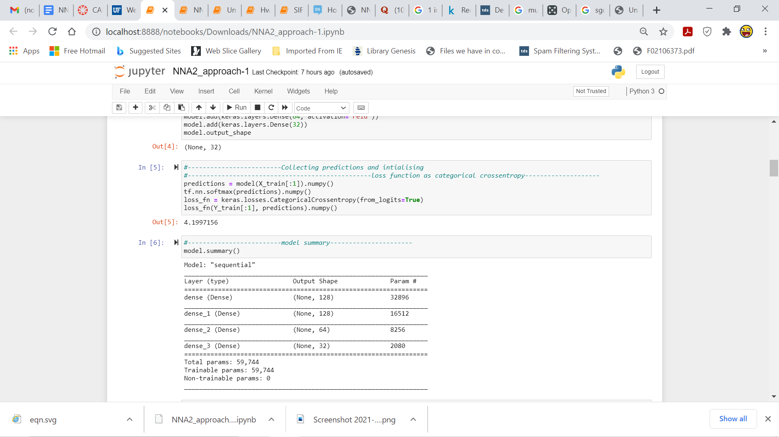

***Initializing the loss function and generating predictions***

The loss function used here is ***Categorical cross entropy*** also called **Softmax loss**. It is suitable for multi-class **classification** especially when the labels are **one-hot encoded**.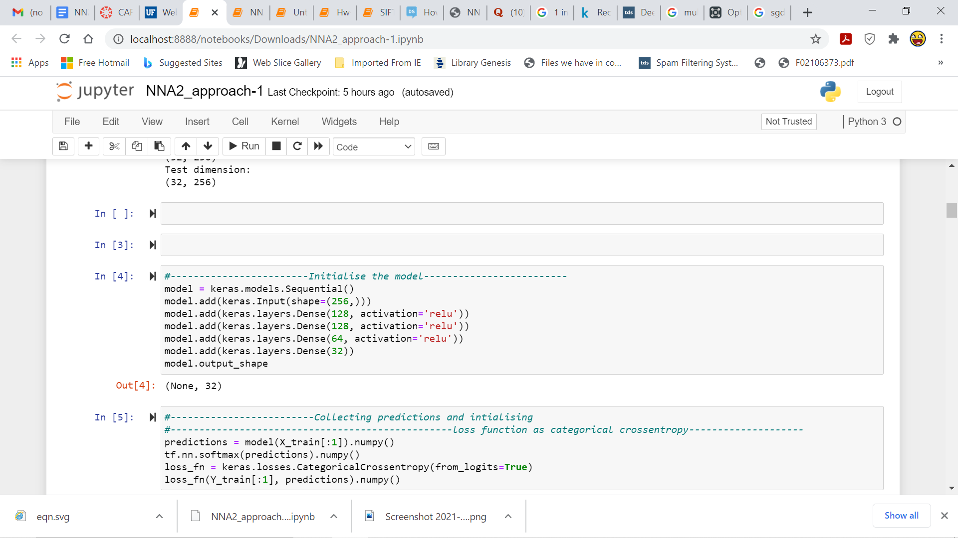

***Compilation and Evaluation of the model***

The following code snippet shows the compilation of the model and the evaluation of the model. The output of one epoch has been displayed and the predictions for the testing set have been displayed as well.

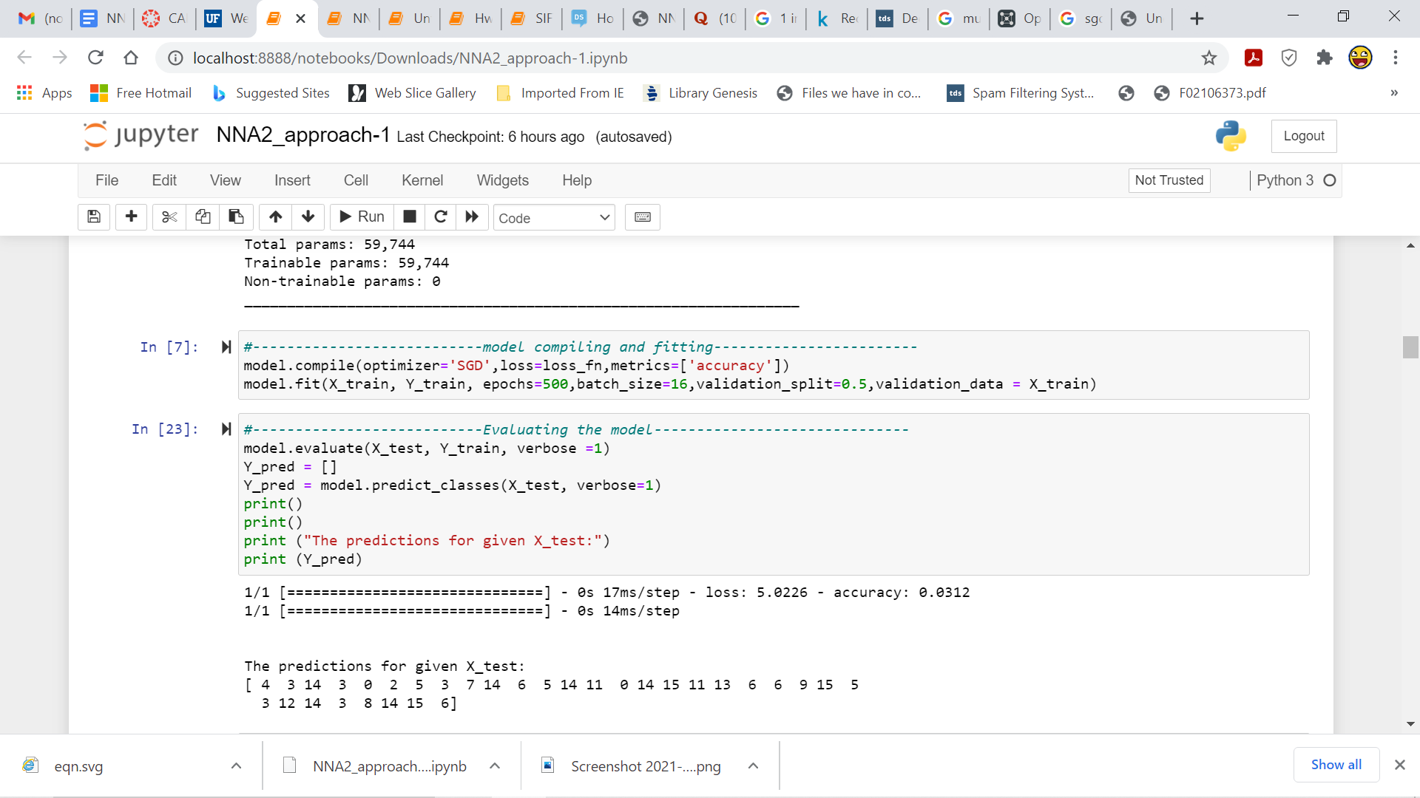

***Calculation of performance metrics for MLNN1***

The following metrics **Fraction of hits** and **Fraction of False Alarms** are calculated with the help of the functions displayed in the code snippet. Then, a graph of Ffa vs Fh was plotted which is shown in **Figure 5.** In addition to this, the **ROC ( Receiver Operating Characteristics**) curve is also plotted along with the **Area Under the Curve** printed which is shown in **Figure 6**. For the Roc curve, the **False positive rate is Ffa** and **True positive rate is Fh.**

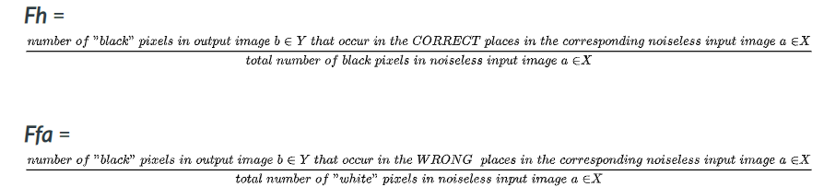

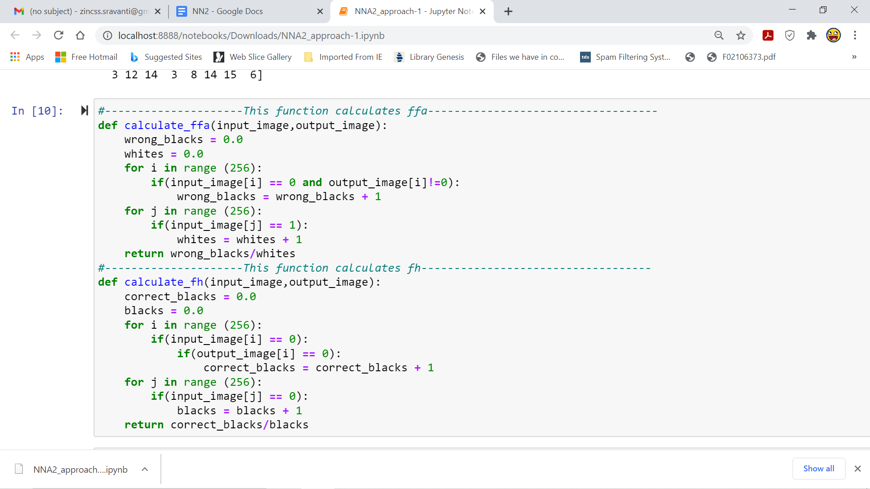

***Plotting the ROC curve***

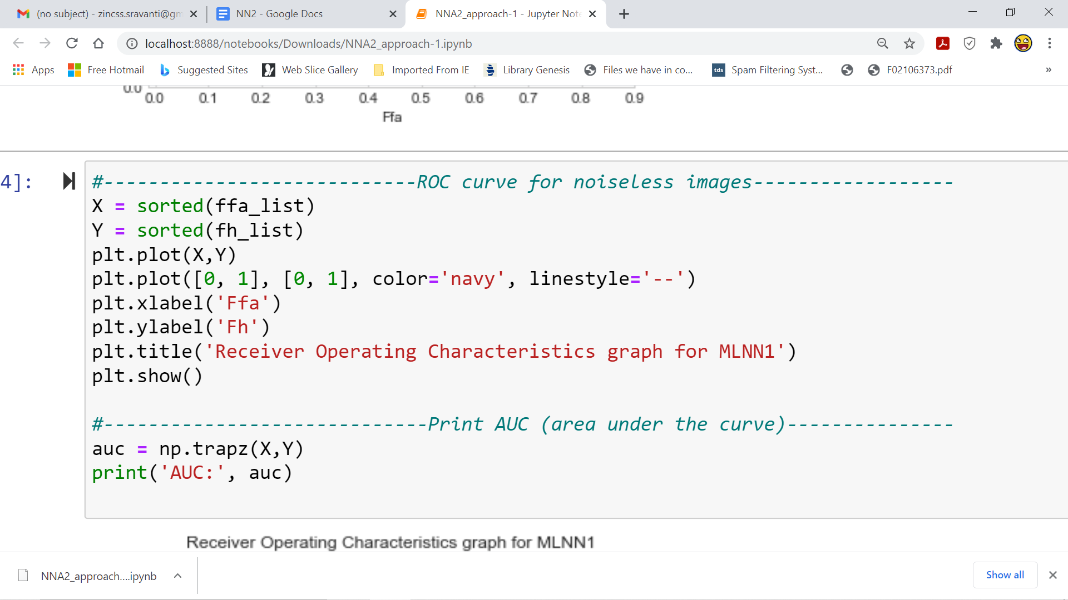

***Introducing noise to input images for MLNN1***

The input images are perturbed by adding Gaussian noise. The following function helps in implementing it.

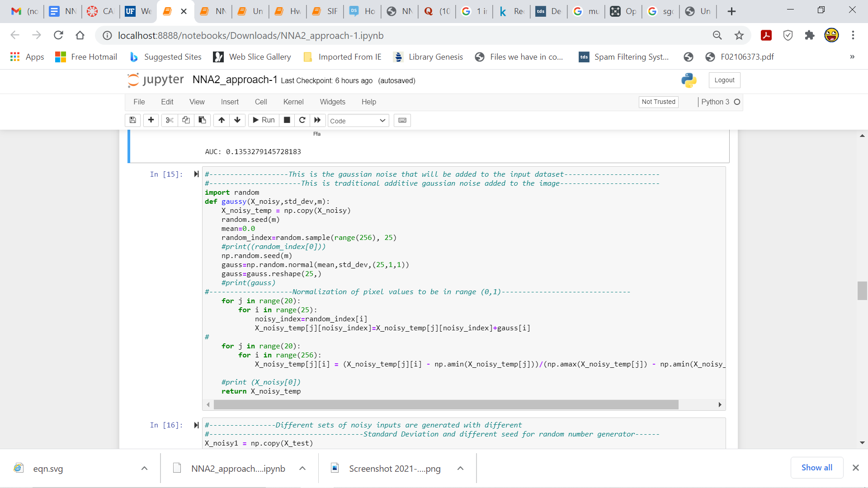

***Calculating performance metrics for noisy images for MLNN1***

Following the training of the noisy images, the **Fh** and **Ffa** values are calculated for the **noisy images** as well with help of the following functions. The functions to calculate Fh and Ffa for noisy images used the **threshold** value which is set to be **0.5** ( that is, **values greater than 0.5** were considered as **white** pixels and those **less than 0.5** were considered as **black** pixels).

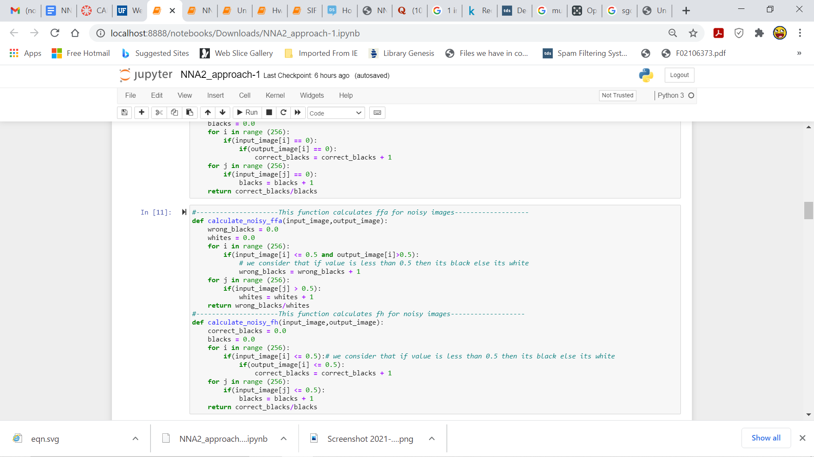

***Plotting the ROC curve***

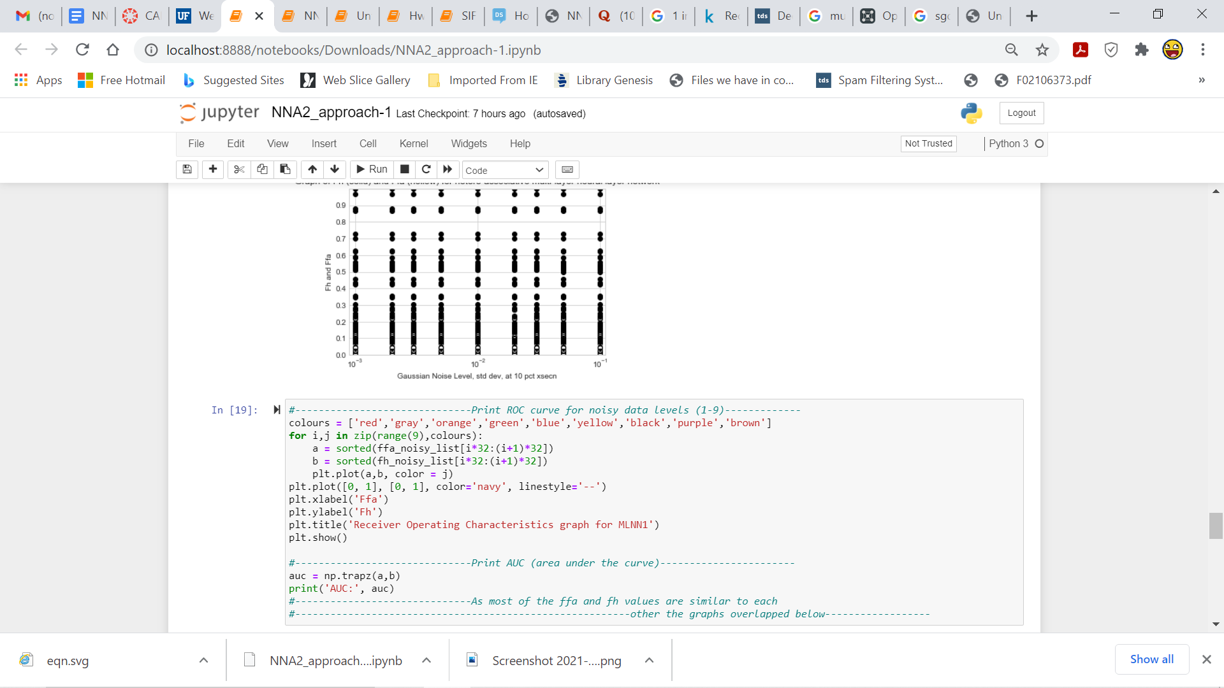

**4.2 Python code for Autoassociative Multilayer Neural Network (MLNN2)**

***Model Initialization***

In the code snippet below the model has been initialized with an input layer, followed by 2 hidden layers and an output layer. ***The TensorFlow*** library has been used. The model was implemented using ***Keras***. After trying several combinations of number of nodes and activation functions, it was noticed that the model performed best when the number of nodes in the hidden layers were ***64 and 64*** and the activation function for each hidden layer is a **sigmoid** function. Tensorboard library was used to chart the variation of loss with the increase in epoch number and visualize the model.

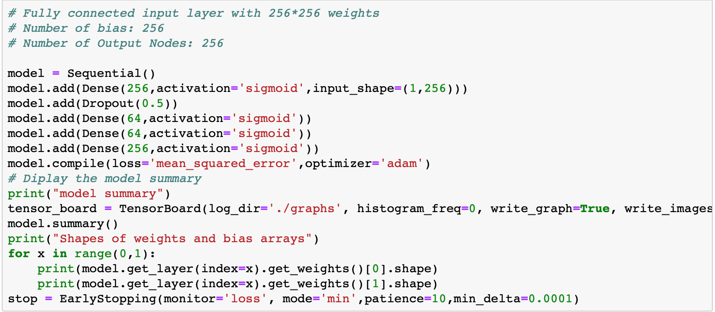

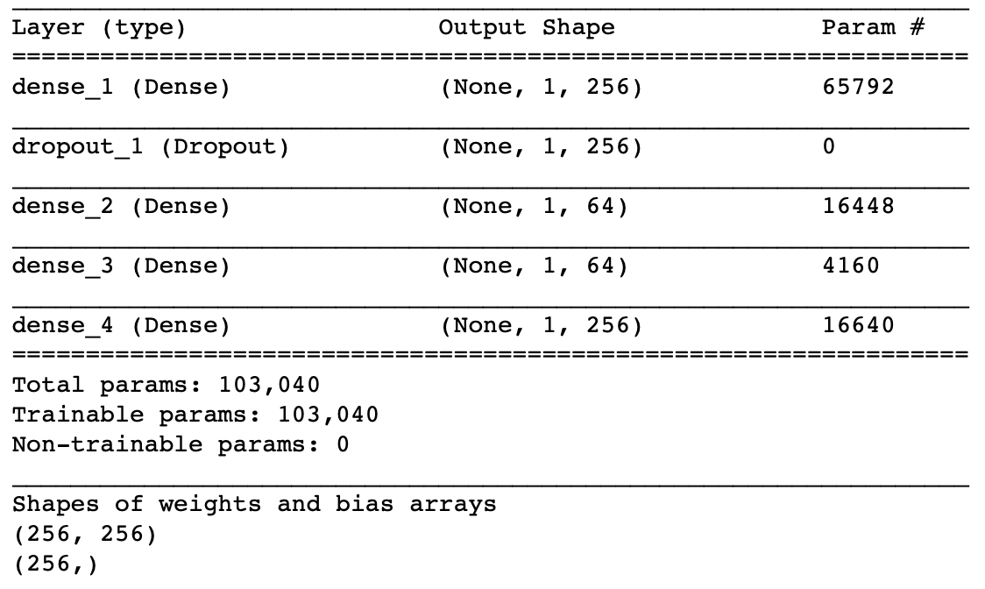

***Compilation and Evaluation of the model***

The following code snippet shows the compilation of the model and comparison of the original image to the image generated by the network. The predictions of the neural network have been attached at the appendix.

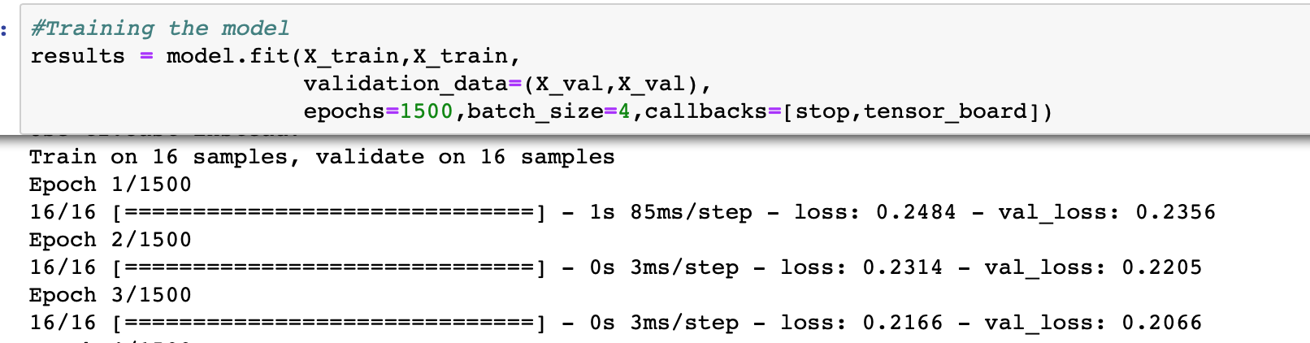

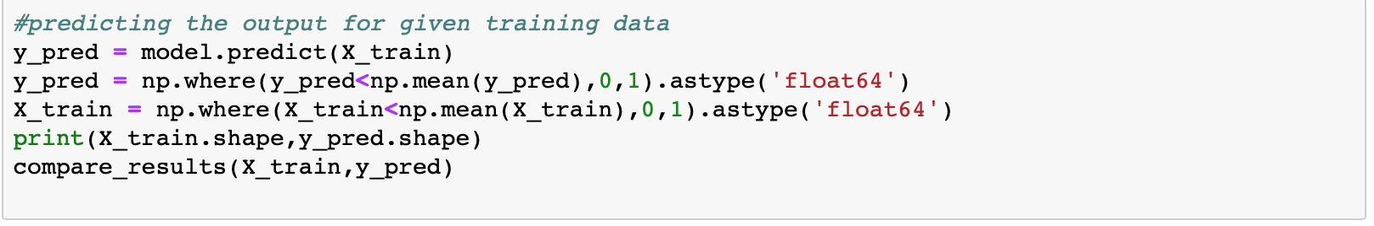

***Calculation of performance metrics for MLNN2***

We calculate ffh and ffa values by comparing the pixels in the predicted images against the original image in the dataset.

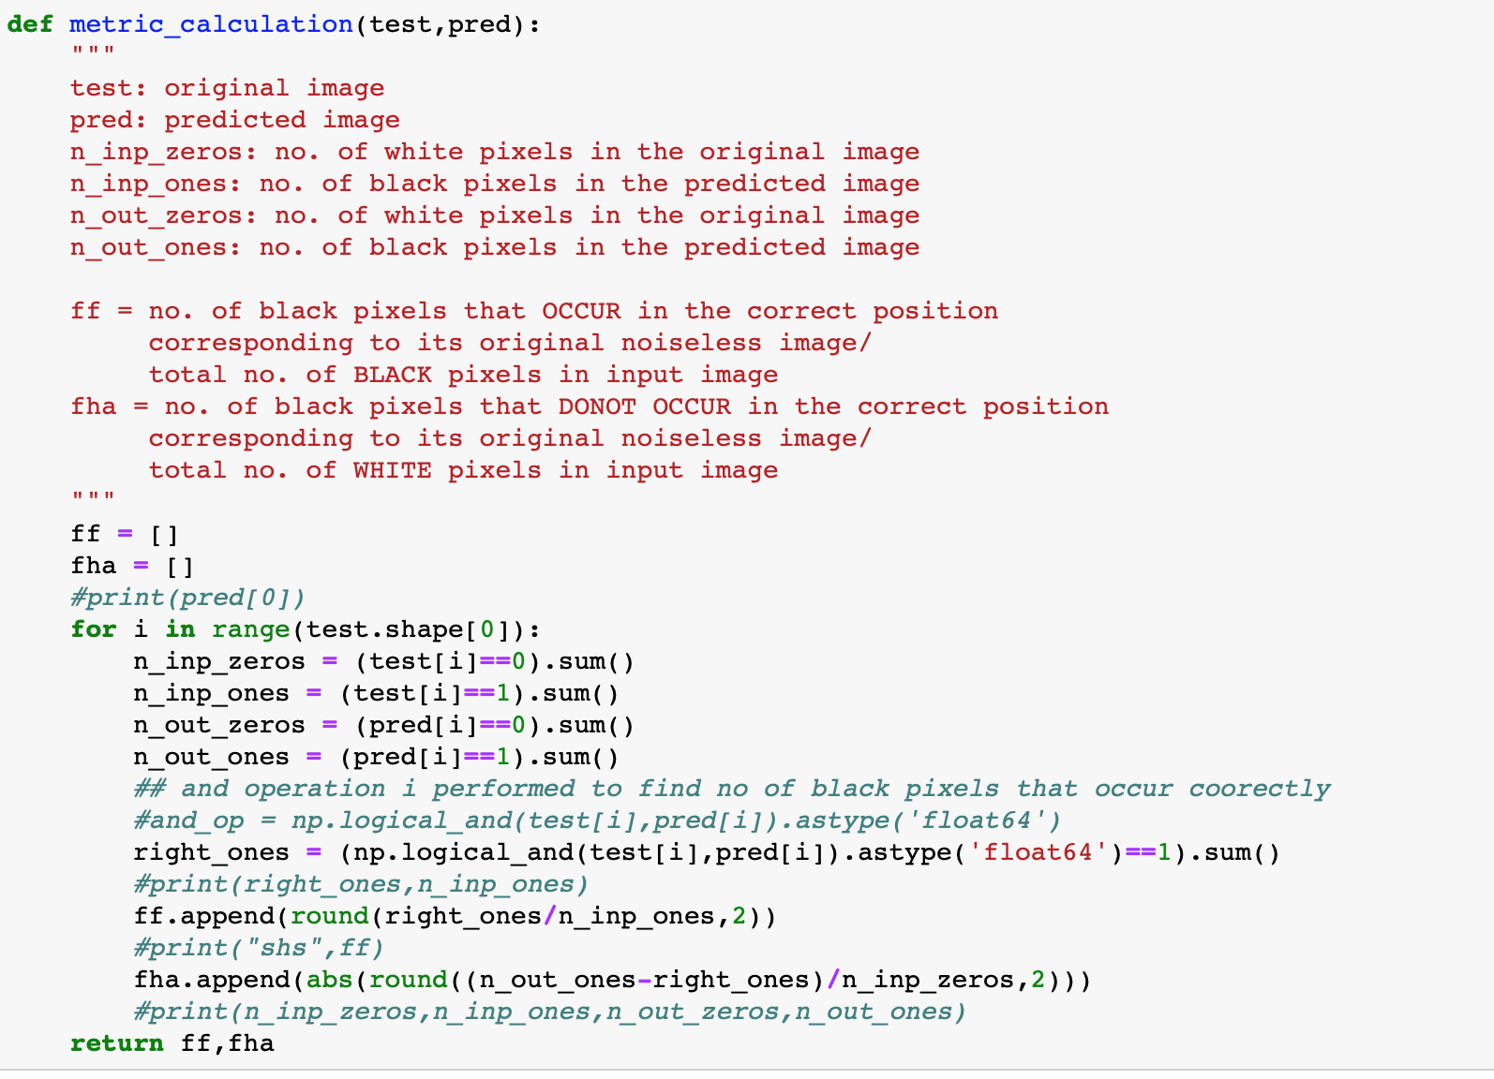

***Introducing noise to input images for MLNN2***

The input images are perturbed by adding Gaussian noise for standard deviations of 0.1, 0.001, 0.002, 0.003, 0.005, 0.01, 0.02, 0.03 and 0.05. The following function helps in implementing it.

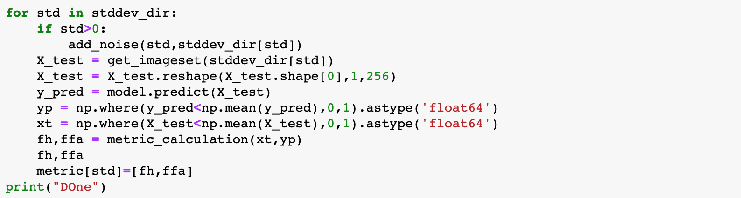

***Plotting ROC curve***

We plot an ROC curve for the entire noisy and noiseless dataset using the following code

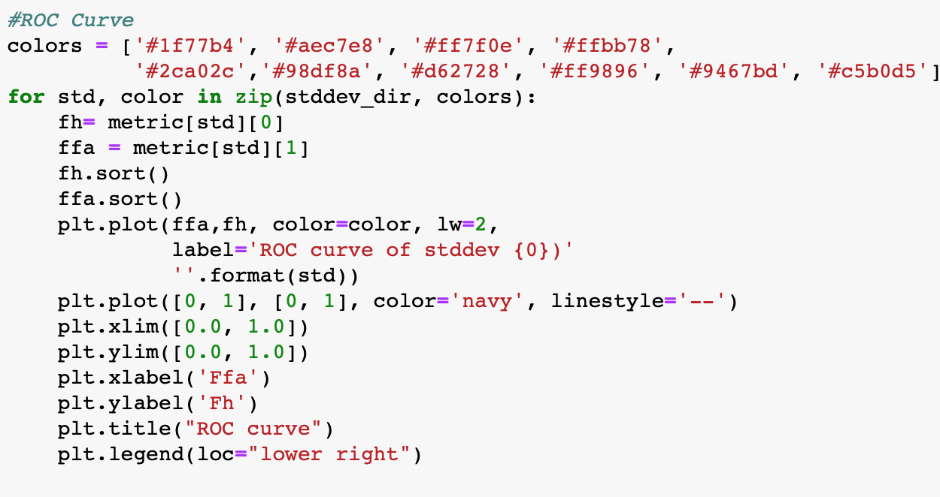

**5. MLNN PERFORMANCE FOR NOISELESS INPUT**

**5.1 MLNN1**

***Output Results For Noiseless Input In Terms Of Fh And Ffa Graph***

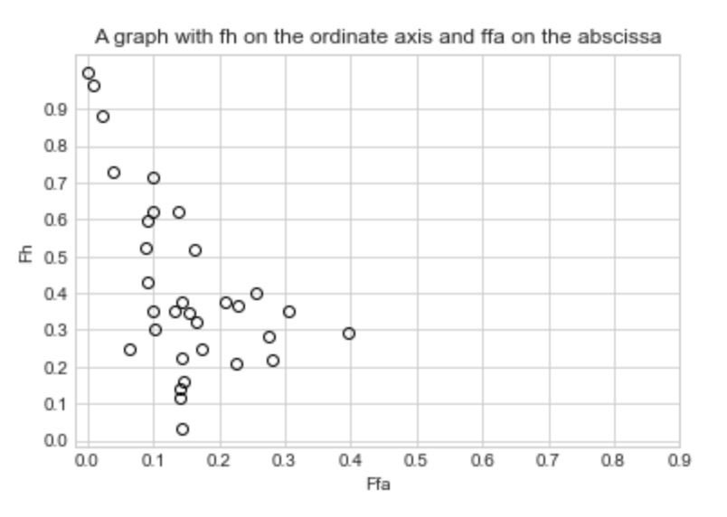

**Figure 11:** MLNN1 Graphical representation of fh and ffa values for noiseless data

***ROC Curve for Noiseless Input***

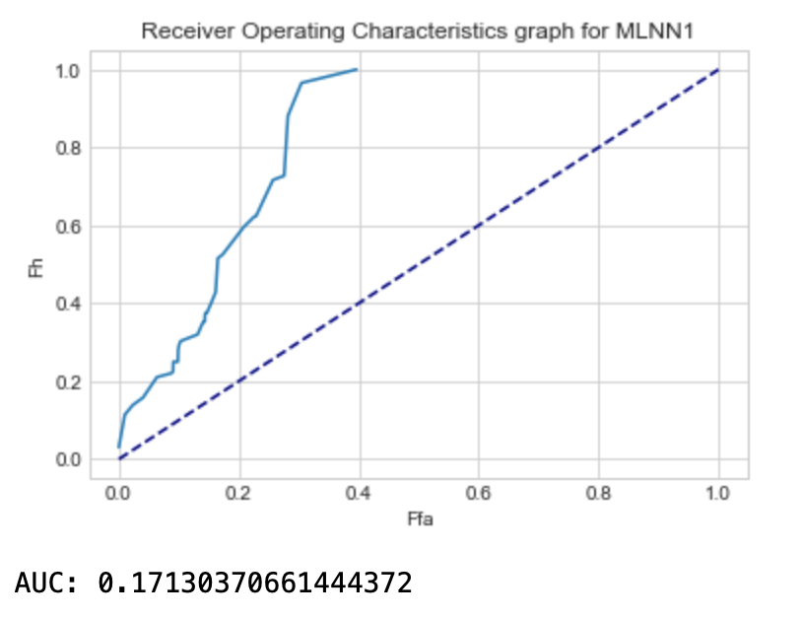

**Figure 12 :** MLNN1ROC graph for noiseless data

**5.2 MLNN2**

***Output Results For Noiseless Input In Terms Of Fh And Ffa Graph***

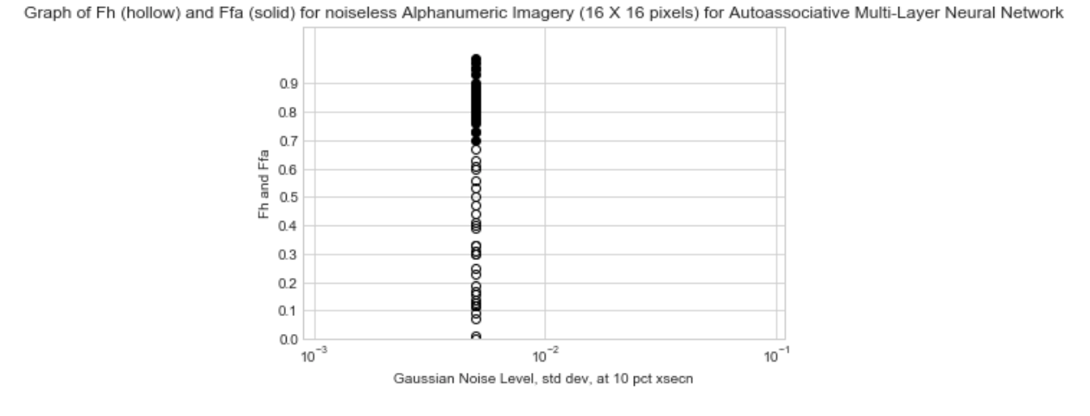

**Figure 13 :** MLNN2 Graphical representation of fh and ffa values for noiseless data

***ROC Curve For Noiseless Input***

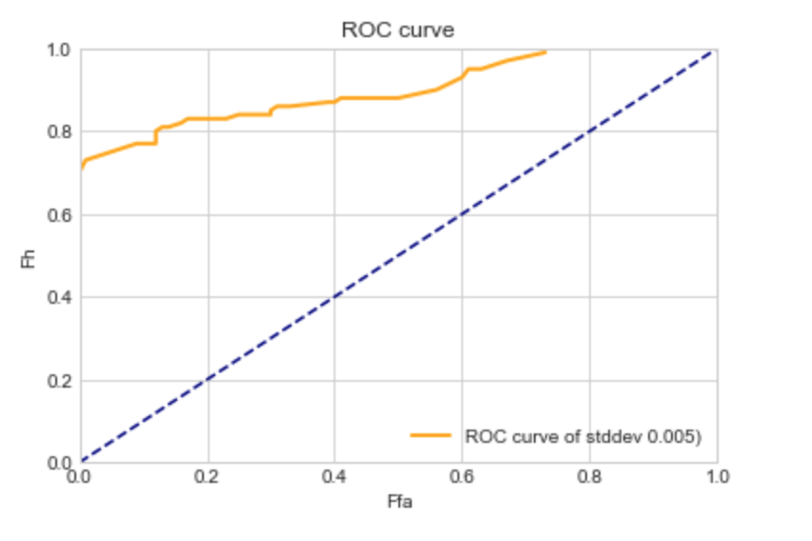

**Figure 14 :** MLNN2ROC graph for noiseless data

**6. MLNN Performance for Noise Corrupted Data**

The images were then perturbed with **gaussian noise** and then the images were then tested.Following which **Fh and Ffa values** for each **standard deviation** were calculated and tabulated below for each model. A **graph** was also plotted with standard deviation on the abscissa and the Fh and Ffa values on the ordinate axis .Although different levels of noises were added it was observed that there were miniscule changes in the Fh and Ffa values. Furthermore, as the standard deviation of noise level increased, the Ffa and Fh values had minute changes which possibly indicates that the changes in the image matrix were so minute with **current corresponding criteria** (**counting the number of black pixels**). It is observed that at low standard deviation a similar amount of noise is added to the 25 pixels that are randomly chosen, so there is no much impact on the performance of the model. Since to plot the **ROC curve the Fh and Ffa values are used**, it can be observed that for each noise level with different standard deviations resulted in a similar ROC curve as there were not much changes in the values of Fh and Ffa for different standard deviations. Hence, the **curves overlap** over each other as observed in each model’s ROC curve graphical representations.

**6.1 MLNN1**

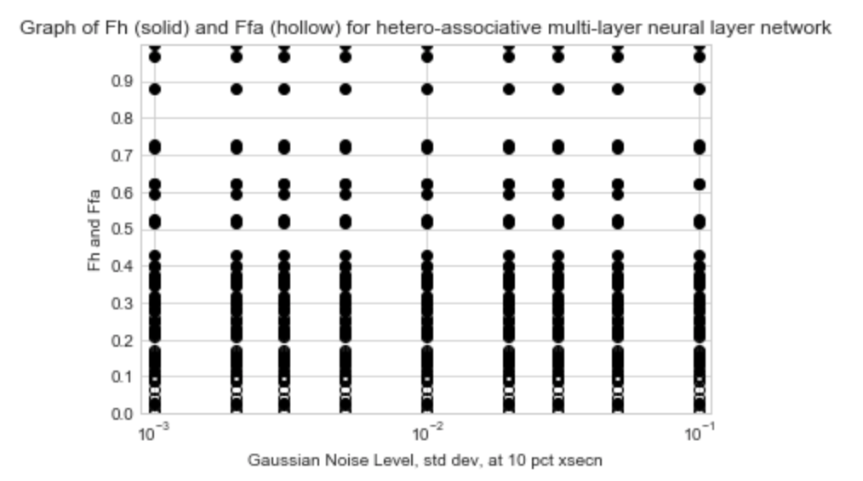

**Figure 15:** Performance graph for noisy data for MLNN1

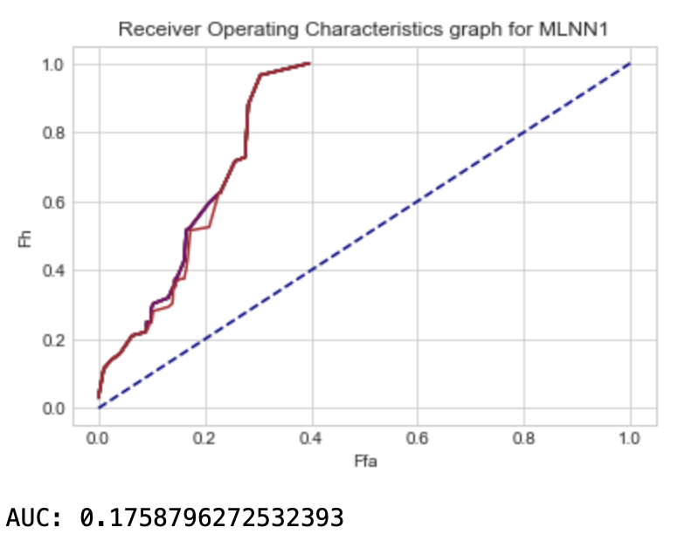

**Figure 16 :** MLNN1 ROC curves for noisy data for each standard deviation

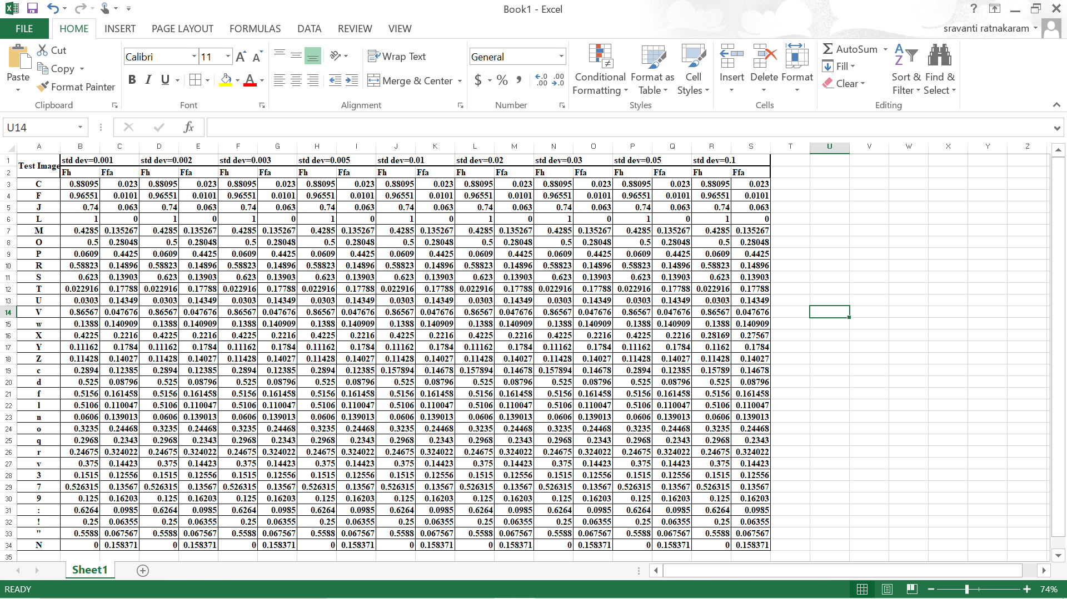

**Table 2:** MLNN1 response to noisy input

**Figure 17 :** Noisy Fh , Ff a values (SD = 0.1)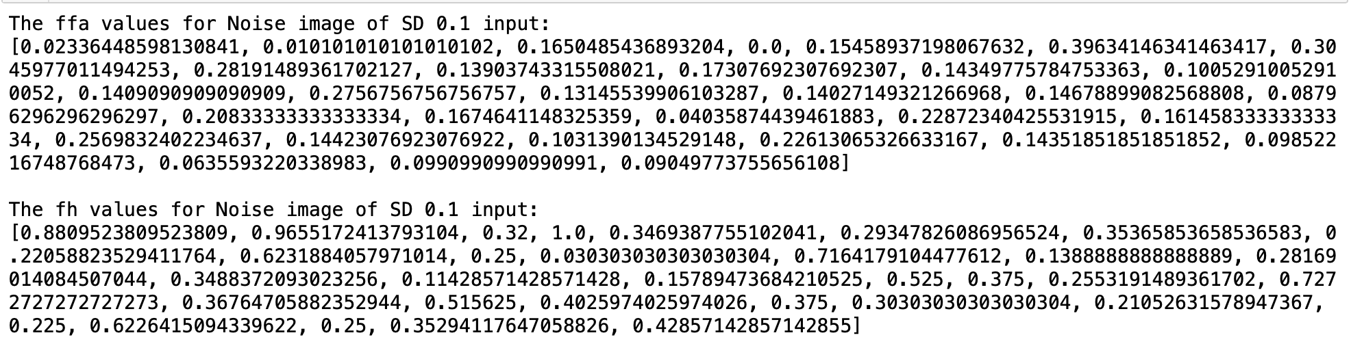

**6.2 MLNN2**

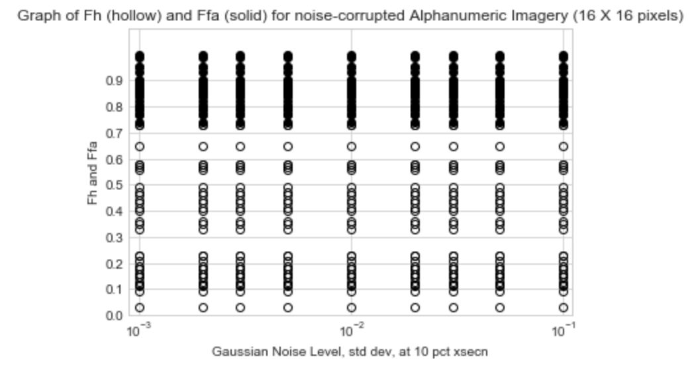

**Figure 18:** Performance graph for noisy data for MLNN2

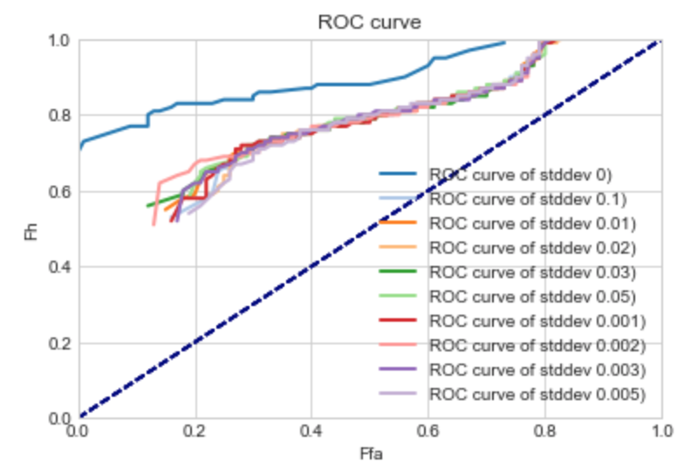

**Figure 19 :** MLNN2 ROC curves for noisy data for each standard deviation

**Table 3:** MLNN2 response to noisy input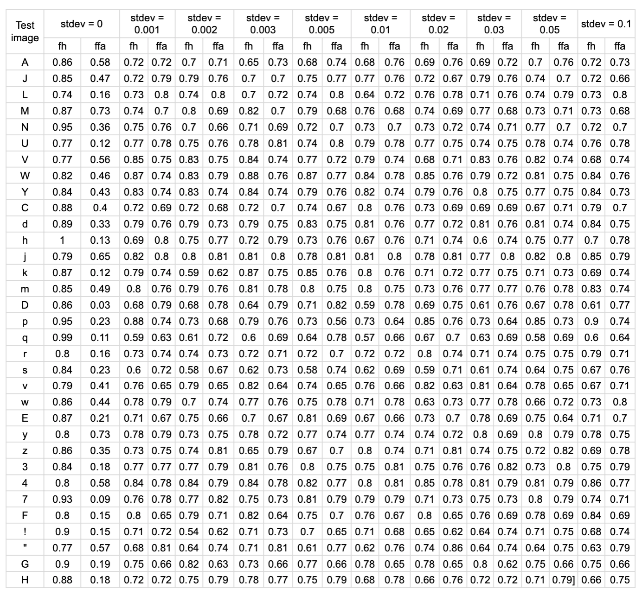

**7. DISCUSSION**

**7.1 MLNN1**

The Heteroassociative neural network performs by outputting an index corresponding to the input image. The labels here are the indices of the images. The model has 3 hidden layers all using the ReLu activation function which functions similar to the linear activation function.It was noticed that the best accuracy was given when the ReLu activation function is used. The number of nodes in each layer were also set to gain the best performance from the model. During testing, it has been noticed that the performance for 500 epochs is given to be around 0.03. The reason for this could be that the testing and training sets were entirely different and the model was not able to identify the testing images exactly but the output was giving a morphologically similar index. One way to improve the accuracy could be to change the labels, rather than using one-hot coding vector, another correspondence mechanism could be used. It was also noticed that as the epochs were increased it led to over-fitting of the model. To improve the accuracy, the training and test sets could be changed as they influence how the model performs. Also, additional hidden layers with other activation functions could be appended to the model to improve the performance of the model.

The noisy data could be generated using another noise function, for instance, salt and pepper noise. The ROC curve for the noiseless data implies that the performance can be better which can be improved by making changes to the layers in the model. The ROC curves for each Standard deviation of the noisy data were the same as the changes in the Fh and Ffa values were minute and the predictions did not change much. Hence, they overlap each other. This could be changed by perhaps adopting another noise function different from Gaussian noise.

**7.2 MLNN2**

MLNN2 model performs well as an autoassociative perceptron, it outputs the image that was given as the input during training. MLNN2 model was built with two hidden layers of 64 neurons each associated with a sigmoid activation. During testing, it was observed that the model cannot identify the exact character. However, it was predicted as its morphologically similar character which implies its identifying different curve, line and orientation similarities in the images. Dropout method is also used in the model to avoid overfitting. Dropout is removing a few neurons so that our model is a generalized model. This improves the model’s ability to classify unseen images accurately. Validation set was selected ensuring it is morphologically similar to the training data and ensure generalization of the model. The choice of characters in the training and validation set influence the efficiency of the model. To improve the efficiency while dealing with noisy data that is fed into the input during testing, another form of adding noise could have been chosen, for instance, here additive gaussian noise was implemented, wherein multiplicative gaussian noise could have given better results.To further improve the accuracy, the training and test sets could be changed as they influence how the model performs. Also, additional hidden layers with other activation functions could be appended to the model to improve the performance of the model.

The ROC curve for the noiseless data implies that the performance can be better which can be improved by making changes to the layers in the model. The ROC curves for each Standard deviation of the noisy data were the same as the changes in the Fh and Ffa values were minute and the predictions did not change much. Hence, they overlap each other. This could be changed by perhaps adopting another noise function different from Gaussian noise.

In future, performance of the model can be further improved by increasing the training set size. This can be achieved by creating duplicates of each character with different font style or orientation

**8. APPENDIX**

**8.1 SIFT Function**

Following is the code for the SIFT function:

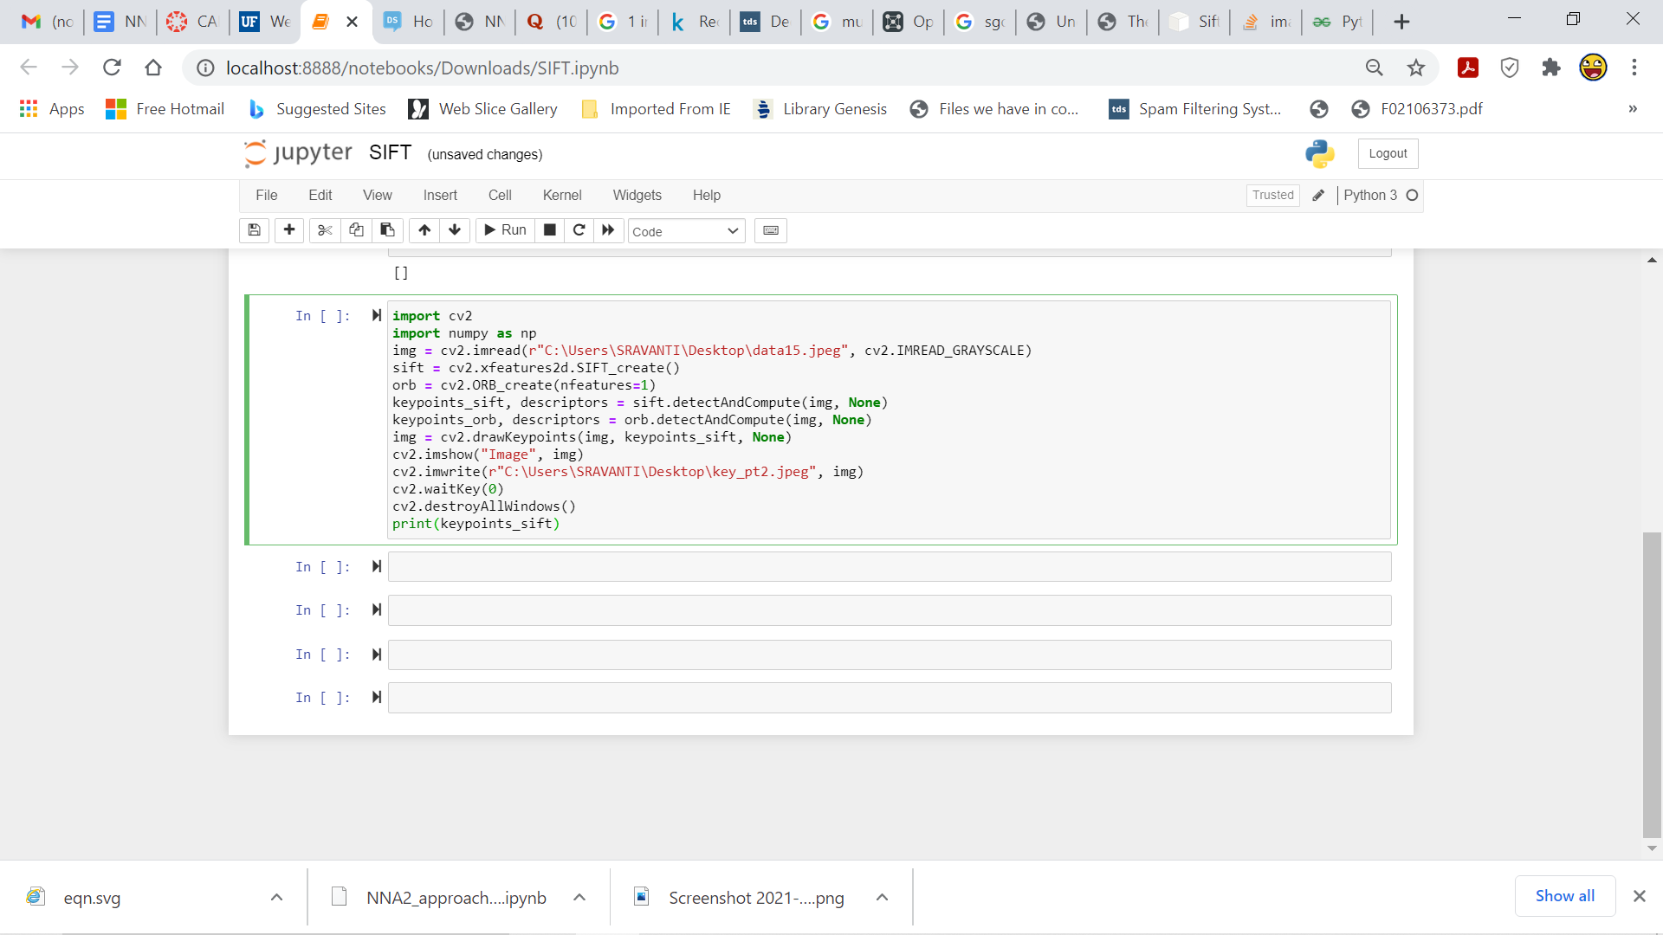

The following observations were made:

If the image had sharp corners, for instance, the alphabet ‘N’, the function was able to identify the KeyPoints but if the image did not have any sharp corners and was a smooth image like ‘O’ it was unable to identify any of the KeyPoints.

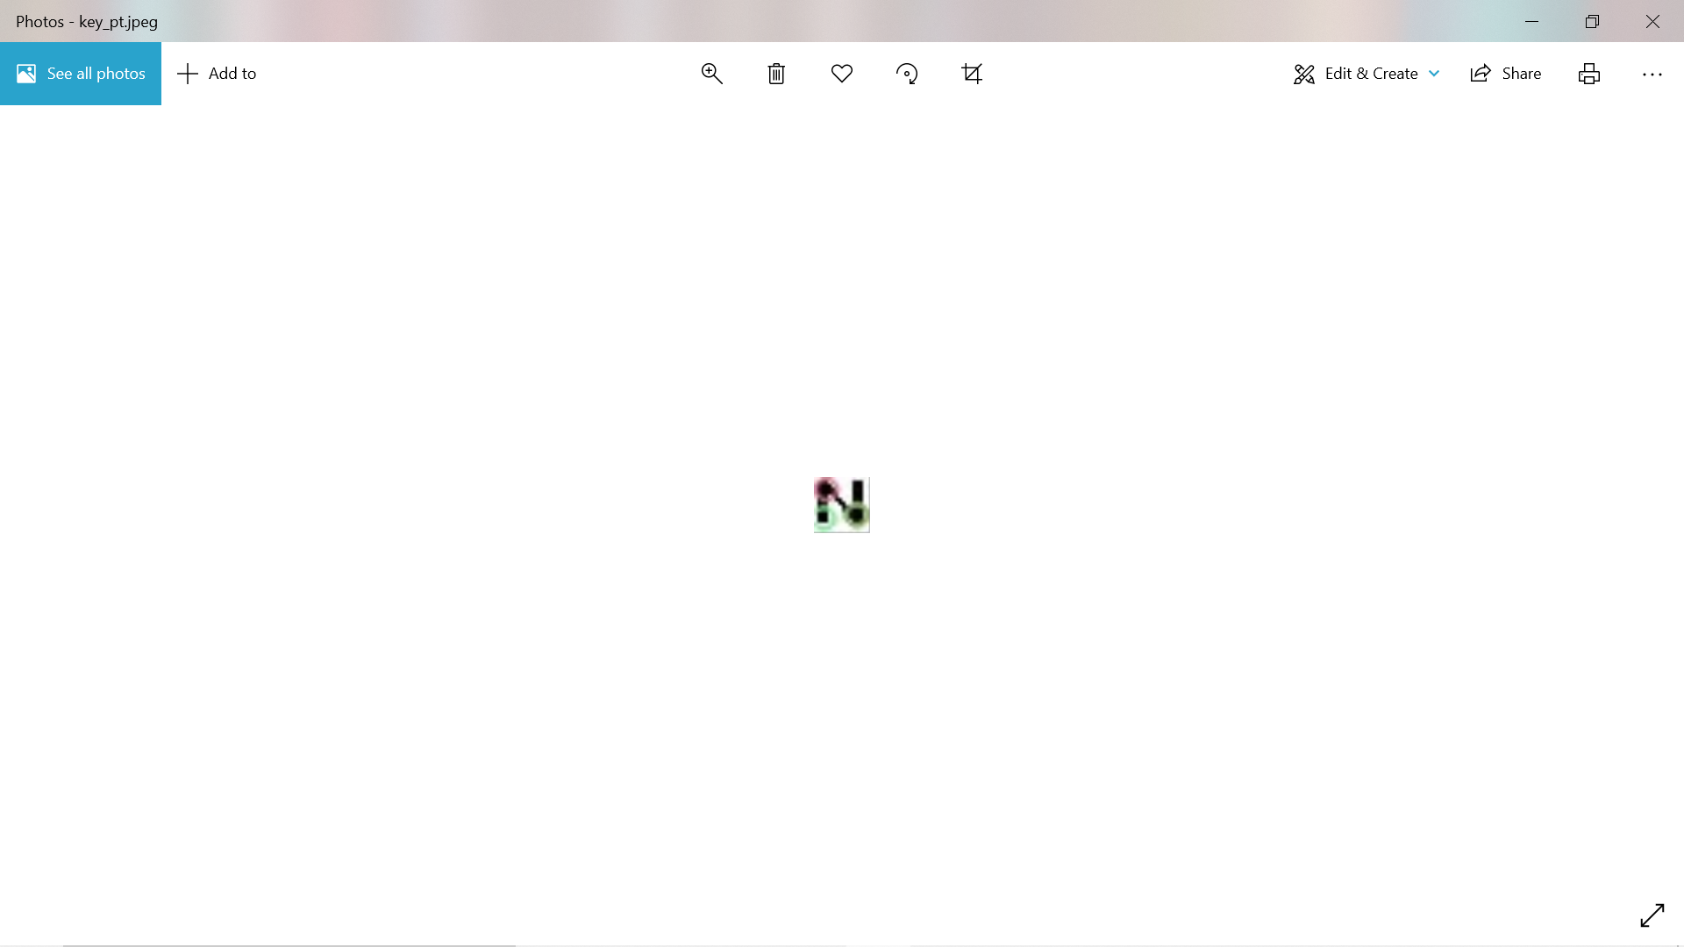

It can be noticed that 3 KeyPoints have been identified.

Similarly, the output for the input image O



It can be noticed that no KeyPoints have been found as the image does not have any sharp corners. Another reason why the SIFT function was unreliable could be that the images were small, they were 16 X 16 images with only 256 black or white pixels. Due to the lack of variation, the function was not able to identify unique key points for all the images in the training and testing set.

**8.2 MLNN2 model predictions**

***Training set predictions:***



***Validation set predictions:***



***Test set predictions:***

